1962-1963 Belmont Braves Basketball
The 1962-63 Senior Boys basketball team coached by Mr. Parrott and Mr. Powell was the most successful in the Braves history (at the time.). The boys finished the regular season with a 6-2 record. Star point guard John Allen led the team in scoring almost every game, including a dominating 46 point performance against Mount Douglas that was believed to be a record for local high school play. John’s point total would stand as a Belmont record for 27 years until Massimo Segato poured in 55 points in 1989-90. Gary Smith was the team’s second leading scorer, while Dave Drummond, Paul Drummond, and Ricky Powell were all strong rebounders and defenders.
At the Lower Island championship, the boys defeated Mount View and Oak Bay to advance to the final against Vic High. This marked the first time there wasn’t a Vic High- Oak Bay final. The Braves put up a strong showing, but lost to the Totems 37-32. The Braves qualified the Vancouver Island tournament, where they finished 4th, defeating Qualicum 53-33 in their final match. Unfortunately for Belmont, the criteria for entrance into the provincial tournament had been changed mid-season, with Vancouver Island dropping from four berths to three, so the excellent season ended at that point.

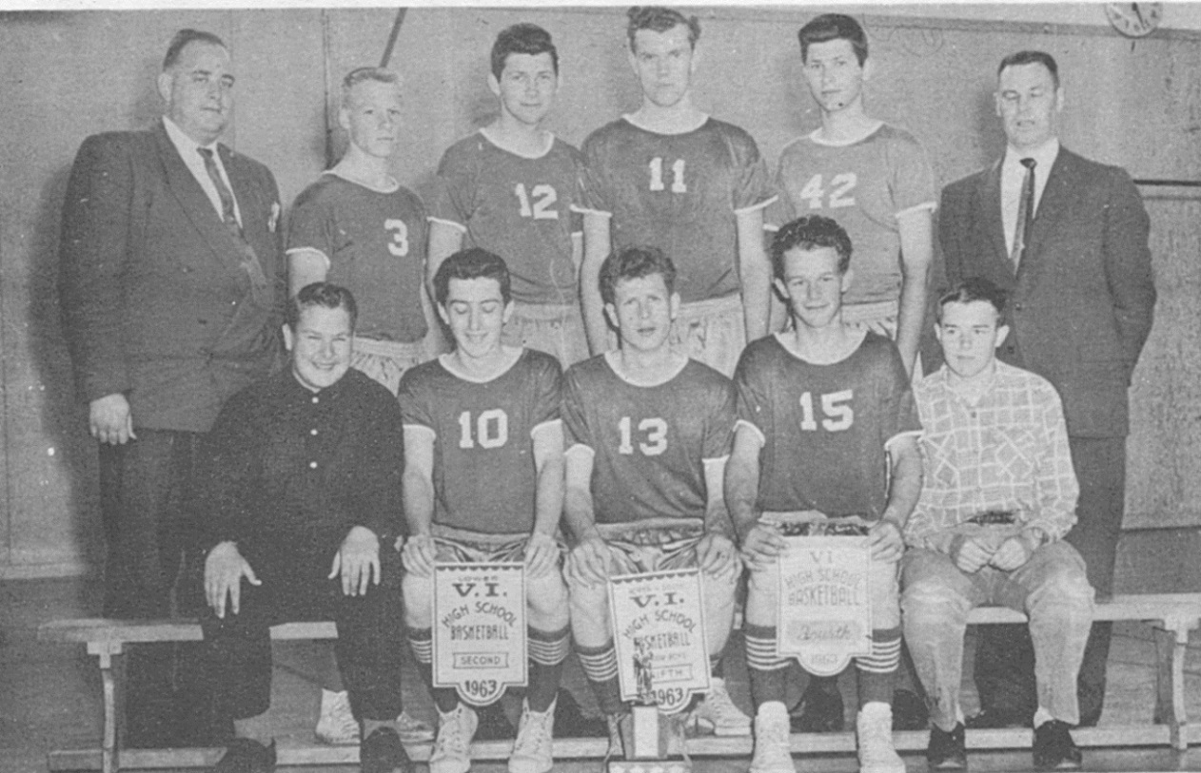
Back row from left: Mr. Powell, Robin Allan, Paul Drummond, Rick Powell, Dave Drummond, Mr. Parrot
Front row from left: Jim Wilson (manager), Lloyd Powell, John Allen, Gary Smith, Norm Arden (manager)

