1969-1970 Boys Volleyball

The 1970 Boys Volleyball team- or “Rinkydinks” as they were nicknamed that year- were probably Belmont’s best volleyball team until that time. With many hours of practicing and commitment by both the team and their coach Mr. Smith the boys finished the season with only 1 loss, competing in the Victoria Senior ‘A’ and ‘B’ league as well as the afternoon High School league.
Some highlights for the Rinkydinks in 1970 were the defeat of Royal Roads, 2nd in the high school division of the Senior Men’s league, and 1st in their division tournament. The boys got an impressive 3rd place in the Vancouver Island tournament and their greatest victory was at the Lower Island tournament when they won every game. Unfortunately injuries held the boys back from the British Columbia finals.

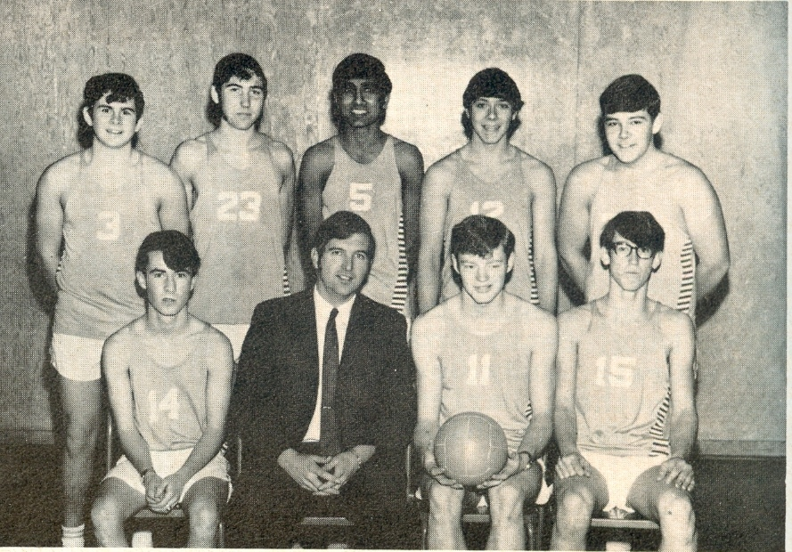
Top Row: (from left to right) Wayne Hendry, Tim Weckend, Assa Manhas, Mike McKenzie
Bottom Row: (from left to right) Guy Shields Mr. Smith, Gene Longson, Barry Alexander

