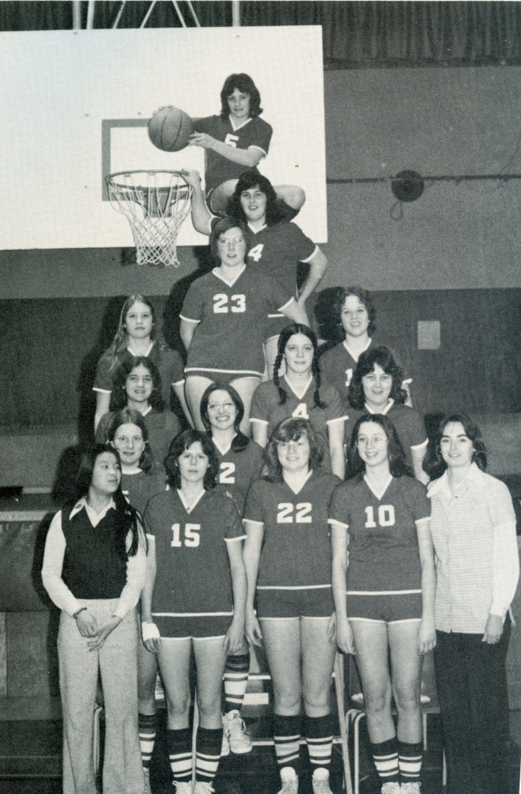
1974-75 Girls’ Basketball
The 1974-75 Tomahawks basketball team, coached by Pam Henson, was the most girls’ basketball team up to that point and accomplished many Belmont “firsts.” Led by captains Pat Charron and Irene Bodman, along with their outstanding guard Sheila Chalmers, the girls recorded a third place finish at the Lower Island tournament. They improved on their standings at the Vancouver Island tournament, surprising some higher ranked teams by working their way to the championship game. Although they came up short against a powerful Vic High squad that featured three future Uvic Vikettes, the silver medal performance qualified them for the BC’s: the first Belmont girls’ team to accomplish that feat. Sheila Chalmers was named to the Island first all star team and Pat Charron earned second team honours.
The Tomahawks performed well at the provincial championship tournament, winning all three games of the initial round robin section, and advancing into the winners’ bracket. Unfortunately they came up against some tough competition in that portion of the tournament and ended up finishing 7th overall. Once again, Sheila and Pat were recognized for their individual efforts, with Sheila being selected as a 2nd team tournament all star and Pat as an honourable mention. Other team members were Janice Bickel, Irene Bodman, Arlene Brown, Michelle Demers, Judy Foley, Cheryl Jackson, Marg Micks, Louise Nowell, Susan Sangret, Deb Sylvester, Connie Thaagaard, and manager Denise Chow.
Back row from left: Mr. Powell , Robin Allan, Paul Drummond, Rick Powell, Dave Drummond, Mr. Parrot
Front row from left: Jim Wilson (manager), Lloyd Powell, John Allen, Gary Smith, Norm Arden (manager)

