1975-76 Swim Team Team
The 1975-76 swim team enjoyed its most successful season in the school’s history. Approximately 25 students travelled regularly to Centennial Pool at the Juan de Fuca Recreation Centre to endure tough workouts coordinated by coaches Randy Smith and Sylvia Dockerill (a national team swimmer who competed for Canada in the 1972 Munich Olympics). A few of the athletes also trained with the Victoria Cohos community club, but the majority were strictly high school swimmers.
The Belmont contingent placed 2nd at the Victoria District meet and followed up that result with another 2nd place finish at Islands. The teams capped off their outstanding season at the BC Championships by placing 3rd overall in the traditional competition and 2nd in the synchronized component. Doug Portelance turned in a sparkling performance by capturing individual gold medals in the 50 meter and 100 meter backstroke races, and earning teaming up with Martin Sabel, Julie Rainey and Lorraine Morrison to capture another 1st place finish in the “A” event freestyle mixed relay. Three other Belmont relay teams took home gold medals: Joan Robertson, Lori Wells, Chris Wheldon and Terry Brown in the 400 meter freestyle; Kim Goronuk and Lori Wells in the skulls relay; and Susan Perry and Chris Blaus in the skills relay.
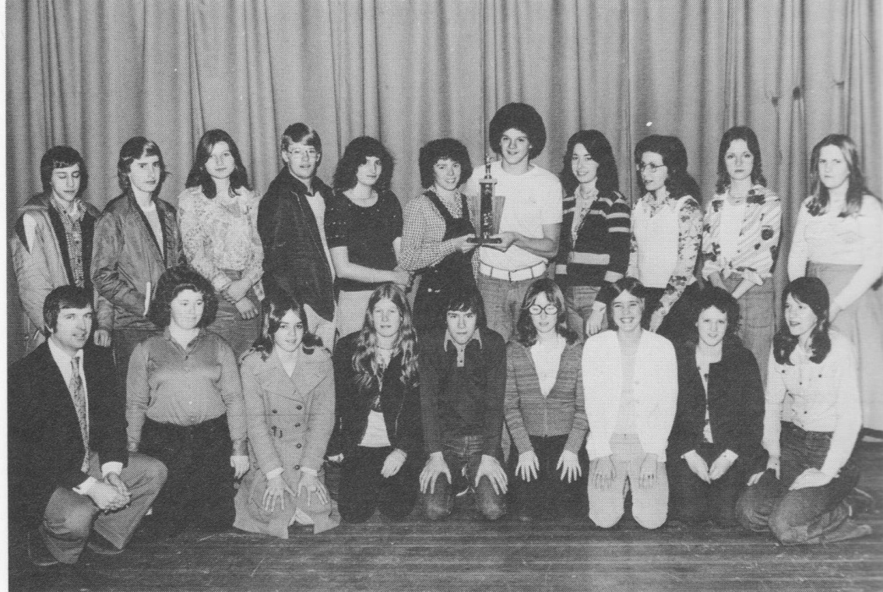
Coach Randy Smith and the 1975-76 Belmont swim team. Triple gold medalist Doug Portelance is holding the trophy with Julie Rainey in the back row.

