1979-80 Cross Country
The 1979-80 cross country teams had an extremely successful season, adding many awards and titles to their name. The boys’ team, led by Willy Fry, Mike Talmon and Lee Harvey the boys achieved 4th in the Greater Victoria league races, 3rd in the Vancouver Island championships and 11th in the B.C championships. The girls’ team was led by Karen Rainey, Karen Coutts and Karen Talmon and finished 1st in Greater Victoria, 1st in the Vancouver Island championships and 5th in B.C. The girls won all but one race (when they placed 2nd) in their regular season.
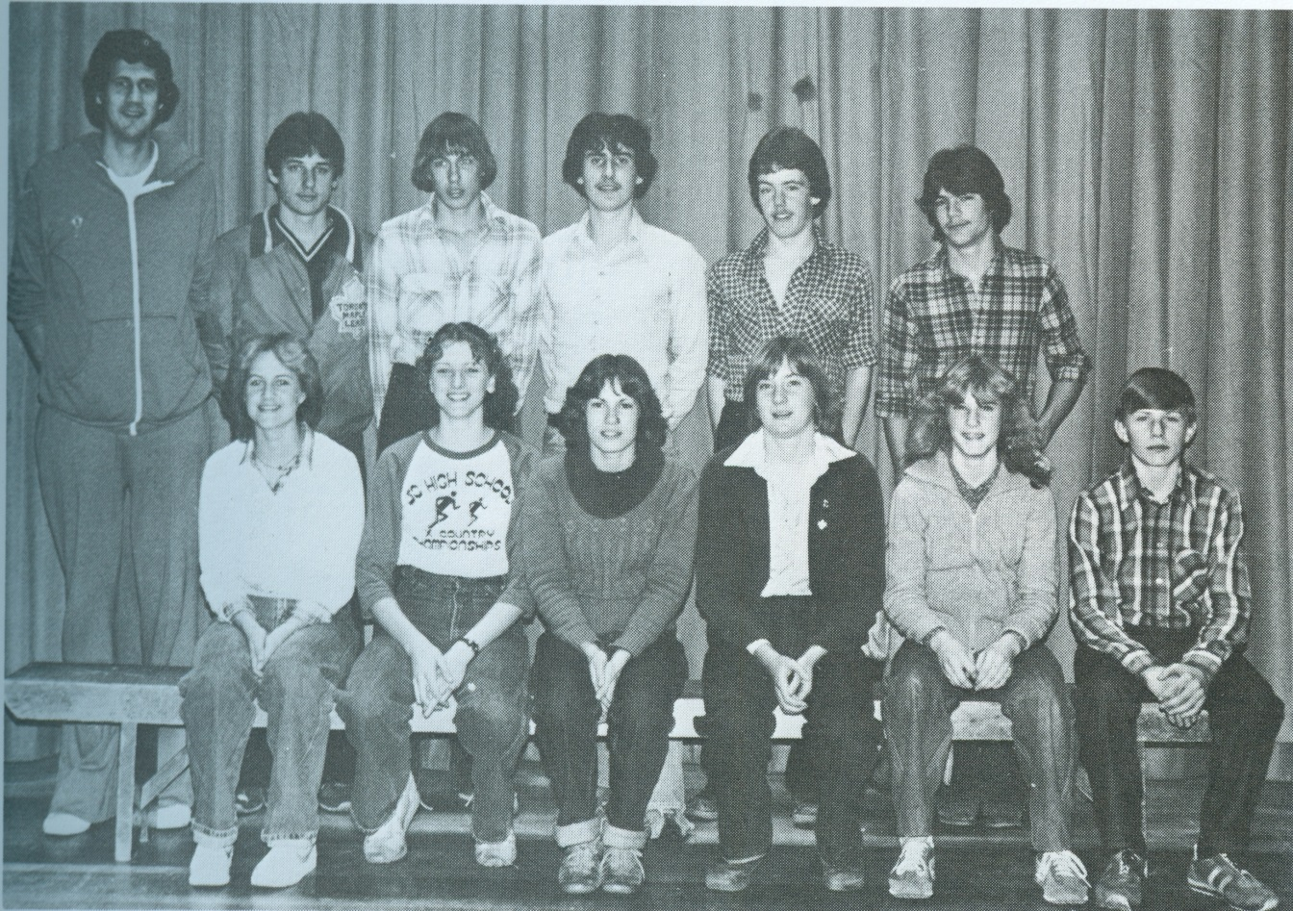
Back Row Left to Right: Coach Tom Holmes, Harry Christ, Kevin Wilson, Willy Fry, Paul Ives, Mike Talmon,
Front Row: Sandy Bjola, Karen Rainey, Karen Talmon, Karen Coutts, Roberta McClellan, Andy Lodges
Missing: Corinne Coutts, Maruen Bodman, Kim Robinson

