1980-1981 Boys Golf
The 1981 boy’s golf team, coached by Rex Johnson, had a great season, winning many tournaments throughout league play. The boys practiced as a club once a week at Royal Colwood, which generously subsidized the program by only charging the students $5.00 per round. Many of the guys also played on their own several more times per week.
Their fine regular season performance qualified them for the provincial championships, held in scenic Radium and Fairmont Hot Springs. The team ended the two day tournament in a three way tie for first place, setting the scene for a sudden death playoff. An errant drive by one of the boys landed in an adjacent fairway on the first tee shot and seemed to spell disaster for the Belmont squad, but an amazing shot salvaged the par and allowed the team to stay in contention and play the second extra hole. In the end, the Belmont boys ended up in second place and took home the silver medals. This was the best result of any Belmont boys’ sports team since the school’s inception in 1947-48.

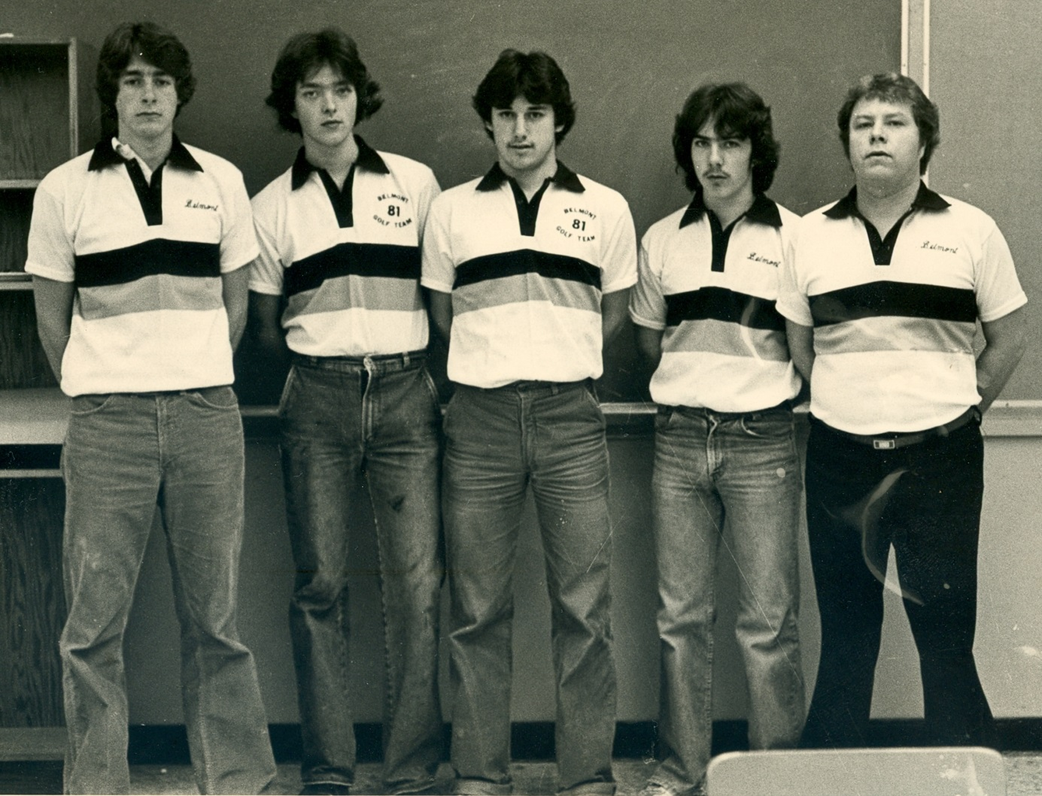
From Left to Right: Guy Spencer, Brian McLean, Harry Christ, Neil O’Leary, and Coach Rex Johnson

