1983-1984 Girls Cross Country
The 1983-84 “Harriers” girls’ cross country team achieved the best result of any Belmont sports team that year at the Provincial Championships, as the girls earned silver medals at the awards ceremony for the aggregate team score. The girls were a strong group all season and won both the Victoria and Vancouver Island Championships. The team was led by Patti Armstrong, who placed 2nd overall at the Islands and 17th at the BC’s.
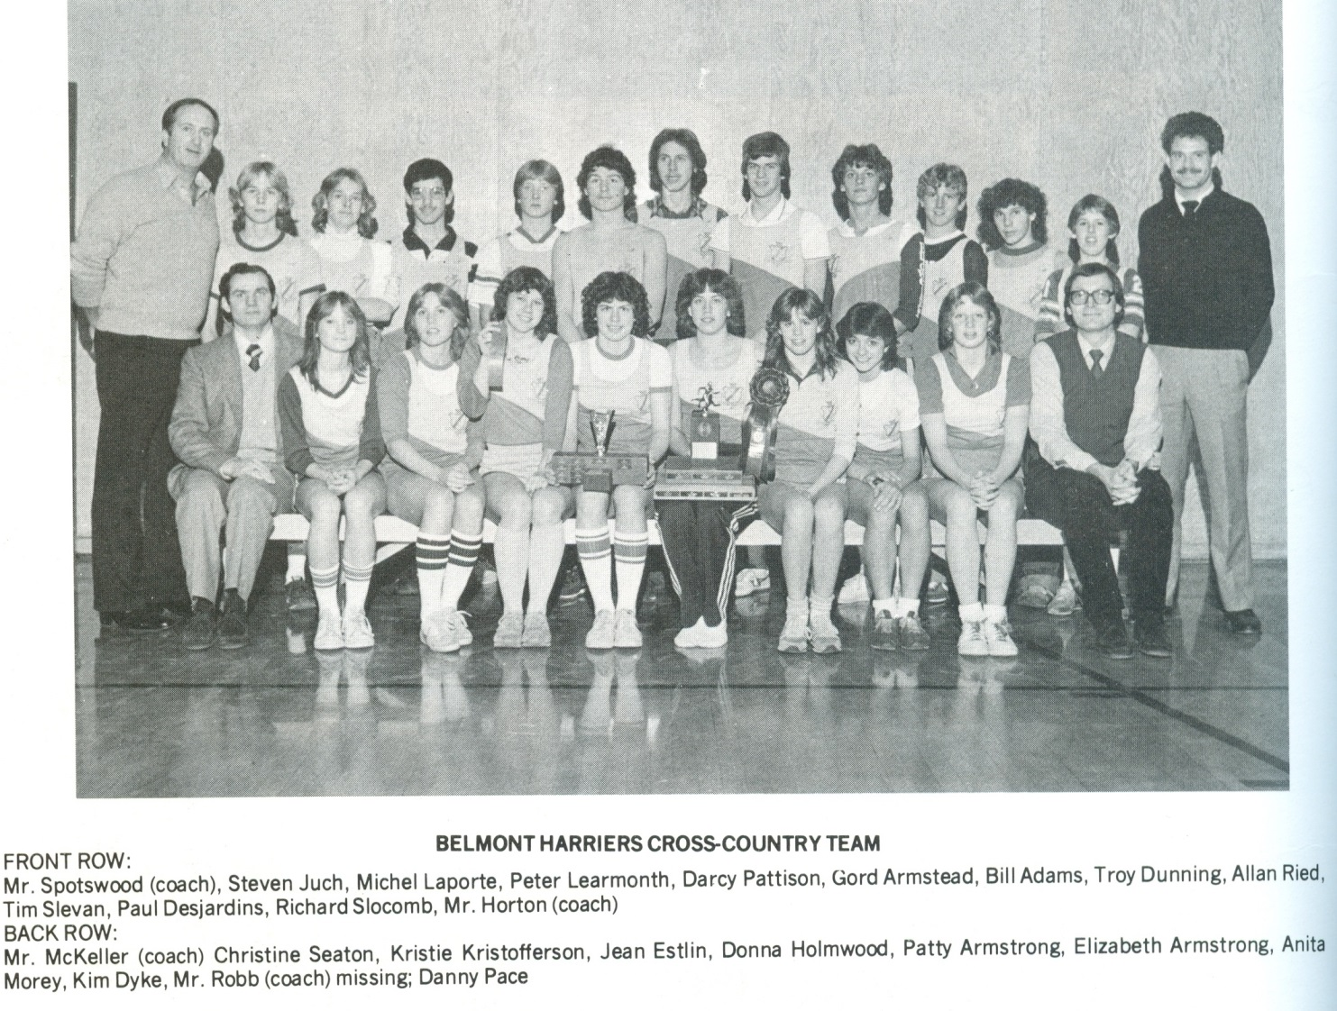
This team photo was scanned from the 1984 Legacy Yearbook and the list of names from the front and back rows have inadvertently been reversed. As can be seen, the girls’ team is seated in the front row with Jean Estlin, Donna Holmwood, and Patti Armstrong displaying the trophies the team won that season.

