1990-1991 Girls Basketball Team
The 1991 Tomahawks, coached by Bill Spotswood and assisted by Cindy Cullen, finished their very successful season with a 35 win and 10 loss record. The team competed against three teams from Maui over spring break and also picked up AAA City and Vancouver Island titles. Lisa Koop was named the MVP of the Island tournament in Port Alberni, while Kirstin Lane, Tami Fowler and Denise Rehman all earned second team All-Star honours. The girls advanced to B.C. championship tournament where they finished fourth overall, just missing out on the medals. Lisa Koop and Denise Rehman were awarded 1st and 3rd All- Star awards at the tournament. In addition, Sheri Griffiths, who unfortunately had to miss the Islands and BC’s due to injury, was one of four players selected from Vancouver Island to play in the B.C. grade 12 All-Star basketball game at BCIT.
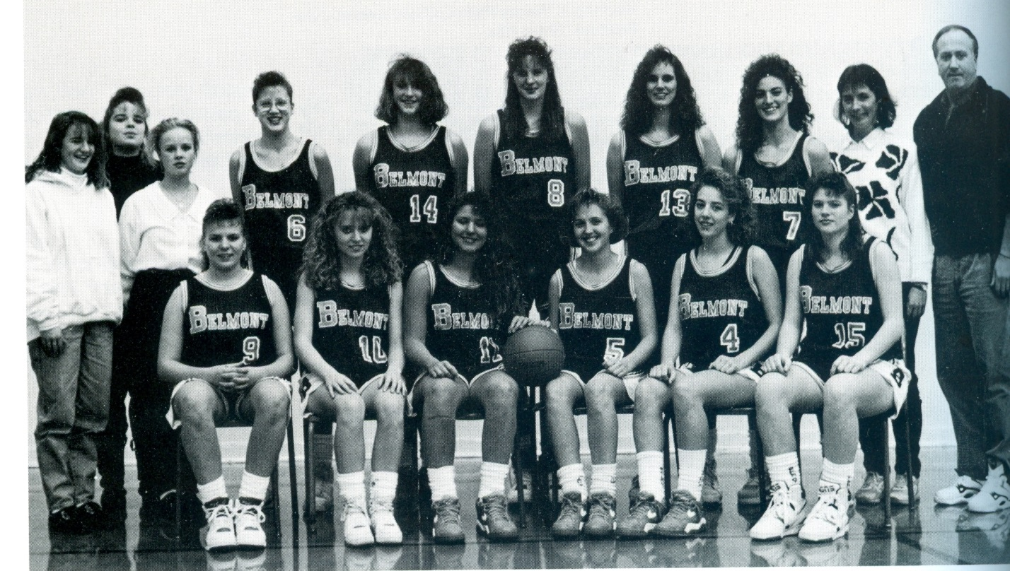
Back Row: Becky Chadwick, Carol Johnson, Renee Bainbridge (managers), Jackie De Raadt, Kindree Spotswood, Denise Rehman, Amber Thompson, Tami Fowler, Cindy Cullen, Bill Spotswood
Front Row: Sherri Griffiths, Shawna Muralt, , Lisa Koop, Kirsten Lane (captain), Kim Hurley Judy Barrett

