2000-01 Girls’ Volleyball
The 2000 Belmont Senior Girls Volleyball Team made school history several times over. A very tight knit group, they began the season unranked, then steadily climbed the provincial AAAA rankings (the first year of AAAA play). The group was led by the stellar play of Grade 11’s Andrea Gollmer, Kathy Anderson, Darla Myhre and most especially senior Nikki Sadowski. On Nov.7th they became the first Belmont Girls Volleyball team to ever reach a #1 ranking. Nov. 9th they would win the inaugural Ron Greene Cup as Lower Island Champions and Dec.2nd at the B.C. Championships they defeated hosts G.P. Vanier in the mother of all semi-finals to advance to the Provincial Championships final. There they would lose a heart-breaker to Centennial and narrowly missed being the first Belmont girls’ team to win a provincial title. The silver medal finish this season, however, laid the base that would lead to a B.C. Championship gold medal the following year.
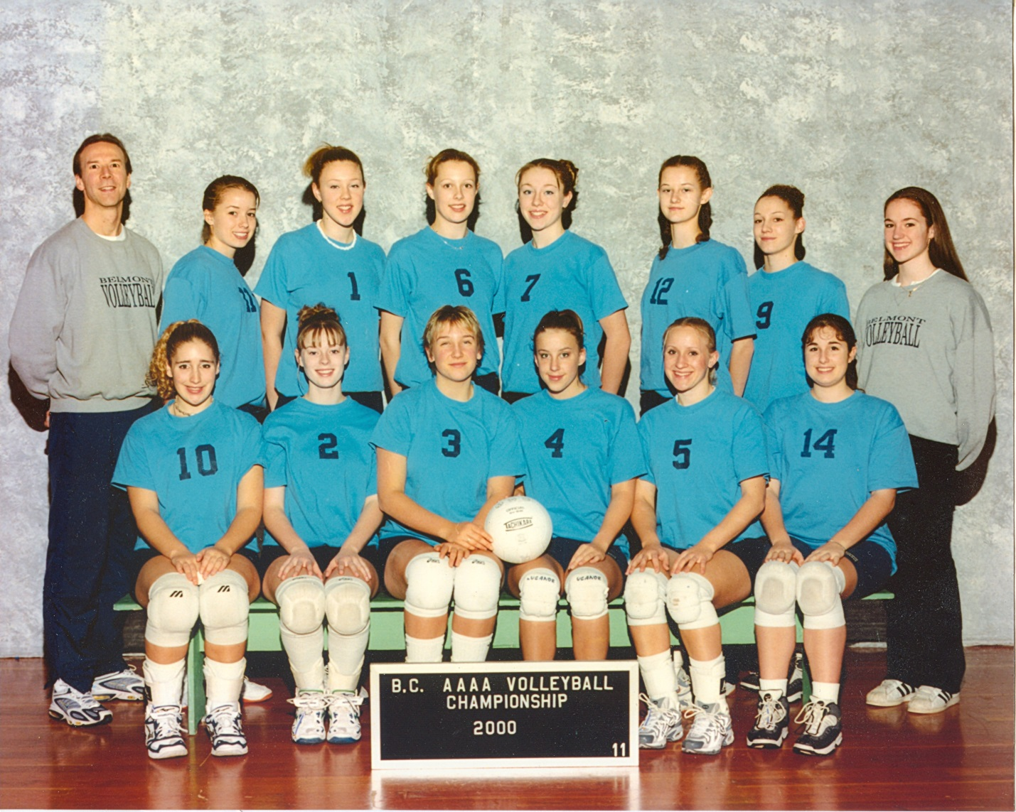
Back Row L-R: Mike Toakley, Thalia Parkinson, Meghan Enright, Darla Myhre, Carly Petillion, Kathy Anderson, Elaine Anderson, Lauren Gallop
Front Row L-R: Andrea Gollmer, Jenny Johns, Nicola Sadowski, Shanna Leek, Pam Badesso, Jackie Rioux

