2007-08 Boys Basketball
The 2007-08 Bulldogs, coached by Muzz Bryant and Tom Holmes and assisted by Lyle Duhr had one of the most successful seasons in Belmont basketball history, capturing the Vancouver Island title for only the second time in the school’s long history. This was an especially satisfying accomplishment, as it marked the first Island championship for Coach Bryant in his illustrious 36 year coaching career.
The Bulldogs were a hard-working group that relied on strong team-work and contributions from all team members. A ten day trip to Hawaii over the Christmas break was a positive bonding experience that forged new friendships and brought the boys even closer together. Besides playing a number of games, the team attended various cultural events, watched a college tournament, and hung out on the beach. By the time playoffs rolled along, they were playing their best basketball of the season, but were still considered a long-shot to qualify for the provincial tournament.
The Island championship tournament was held in Port Alberni, and Belmont opened with a huge 71-61 victory against the defending champions from Dover Bay. This propelled them into a semi-final match-up against the perennial powerhouse team from Oak Bay. The Bulldogs continued their improbable march to the final by knocking off the Bays 90-79 in an intense high-scoring match. In the final game against Mt. Douglas, the Langford boys prevailed with a 68-61 victory. This qualified the team for the BC championship tournament in Vancouver, where they placed 12th in the province.
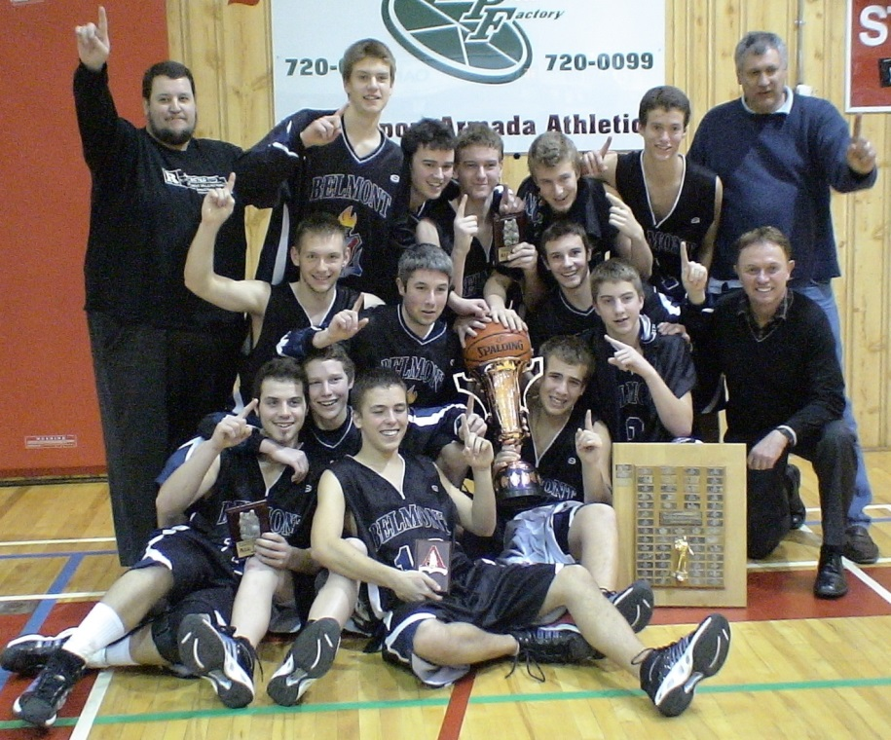
Co-captains and grade 12 guards Craig Lesquesne and Tristan Hall led the Bulldogs on and off the court. Both boys were named as Times Colonist all stars, and along with 6’7” team-mate Alex Sadowski, were selected to play in the Vancouver Island “A” all star game. Other team members included point guard David Shilling, sharp-shooting perimeter players Evan Verdal, Dallas Cullen, Cody Bayliss, Jeff Conway Jones, and Jeff Helgeson, and strong post players Matt Parten, Brad Galloway, Owen Enright, and Cameron Goes.
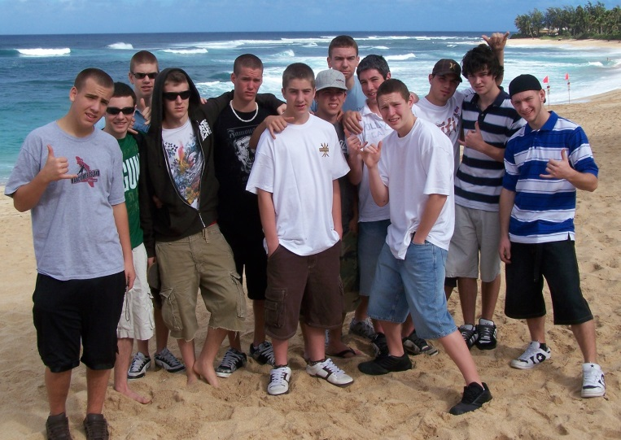
Team photo on the beach in Hawaii, December 2007
The boys celebrate with the Vancouver Island trophy

