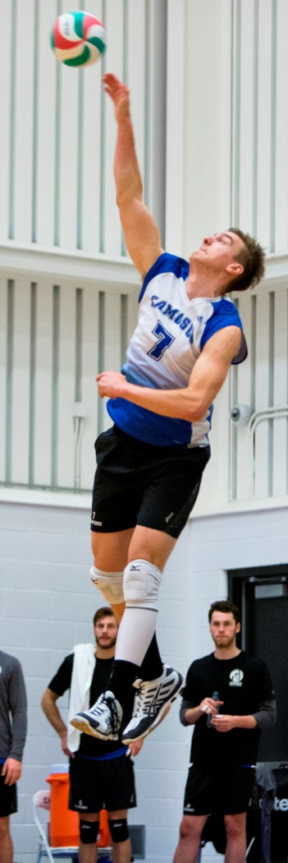
Alex Sadowski: 2005-2008
Alex Sadowski was a multi-sport athlete who was a key contributor to several of Belmont’s athletic teams during his three years at the school. He was involved in a variety of community sports as a youngster, including soccer with the Juan de Fuca association and Langford fastball. He first started playing volleyball in grade 5 at Wishart Elementary, and didn’t take up basketball until his grade 10 year at Belmont. His older sister Nicola, also a Belmont Hall of Fame athlete, was a big influence upon Alex when it came to sports, and like her found volleyball to be his passion.
Alex had a number of impressive sporting accomplishments at Belmont, including being named as a first team all star at the Island Championship tournaments in both volleyball and basketball during his senior year. He was also one of the top shotput and discus athletes on the Island. However, Alex remembers the team successes as his best Belmont memories: in particular, going to provincials with the volleyball team in grade 11 and winning the Island title and going to the BC’s in basketball in grade 12. He still recalls the satisfaction of cutting down the net after winning the final game of the basketball Island tournament in Port Alberni.
After graduation, Alex took a few years off from organized sports, but then joined the Camosun Chargers volleyball squad and quickly emerged as one of the top middle blockers in the conference. Known as the “Big Sadowski” by the Chargers home game announcer and as “Mark” by his team-mates, Alex was selected as PACWEST rookie of the year in 2011-12, and a three-time conference first team All Star. As well, his excellence in the classroom helped him earn CCAA Academic All Canadian honours for two consecutive years. The culmination of Alex’s Charger career came in 2015 when he helped lead the team to its first ever Canadian championship and was named to the tournament All Star team.
Sports have played a central role in Alex’s life. He explains that “Being constantly motivated to work towards a goal has helped improve both my athletic and academic endeavours. Sport has also been a great medium for me to meet friends and create amazing relationships,” He credits a number of people for helping to achieve his success, including his Belmont basketball coaches Muzz Bryant and Tom Holmes and volleyball coach Lee Phillips. However, his biggest influence was his older sister Nicola, who competed in figure skating for many years, as well as playing volleyball at the post-secondary level.
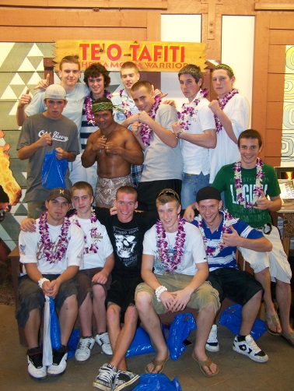
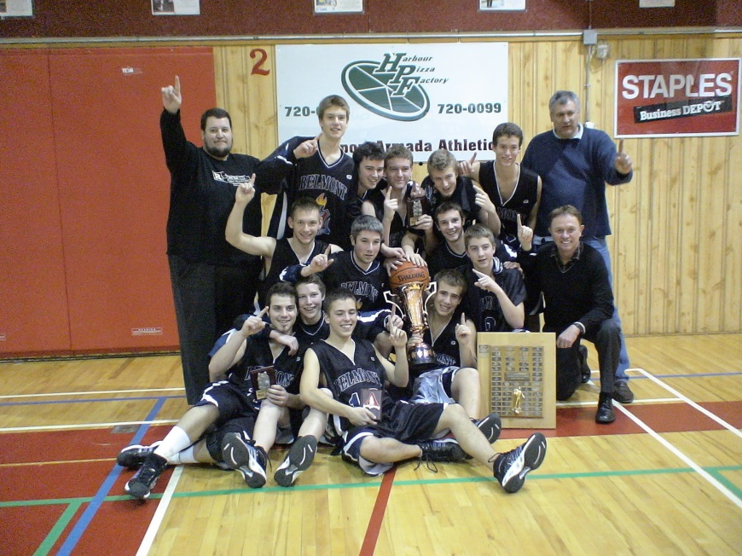
Alex’s advice to current Belmont student-athletes is to take as many opportunities that you can to travel, spend time with friends and family, and don’t sweat the little things. You’re only young once!
Left: Alex and his team-mates celebrate winning the Island basketball title in 2008. Earlier that year, the team travelled to Hawaii for a 10 day trip.

