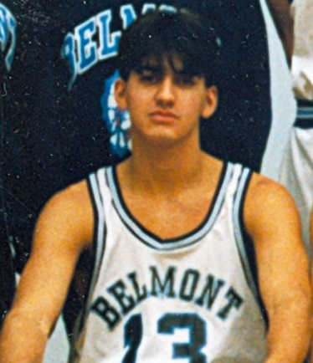
Amrit Lalli: 1990-1992
Amrit Lalli was a basketball and volleyball standout who helped the basketball Braves develop into one of the elite teams in the province. Athletics were always a part of Amrit’s life, even as a young child, as he started playing field hockey at the age of four and later became a competitive swimmer. Basketball didn’t enter his life until the age of 13, when his Spencer Junior High School coaches Peter Songhurst and Gary Mols introduced him to the sport. By grade 10, Amrit was a leader and standout player on the Spencer Knights squad that won the provincial championship: the only Spencer basketball team to ever accomplish that feat. The title was even more impressive when you consider the Knights defeated an Arbutus team that featured star point guard Steve Nash!
Amrit considers his top sporting accomplishment at Belmont to be a third place finish at the 1991 BC High School Championship tournament and being selected a first team provincial all star. His best memories revolve around the relationships he developed with his team-mates and include the road trips and the opportunity to compete with great friends at the highest level in BC high school sport. He credits a number of coaches – Peter Songhurst, Gary Mols, Muzz Bryant, and Bryn Barker – as being particularly positive influences in his basketball career.
After high school graduation, Amrit was recruited by the Uvic men’s basketball coach and went on to play for the Vikes, while earning his Bachelor of Commerce degree. He also met his wife at Uvic and the couple now have two children. Amrit believes that his basketball experience has impacted his life in many ways and still factors into decisions he makes as an adult. He explains that “I refer back to my accomplishments and disappointments on the field of sport when I am faced with decisions in business. My competitive edge has also allowed me to succeed in business” Although he no longer has individual goals for himself with the sport, he is excited about the opportunity to coach his son and his friends.
Amrit’s advice for current Belmont high school athletes today is to ”do what you love the rest will follow.”
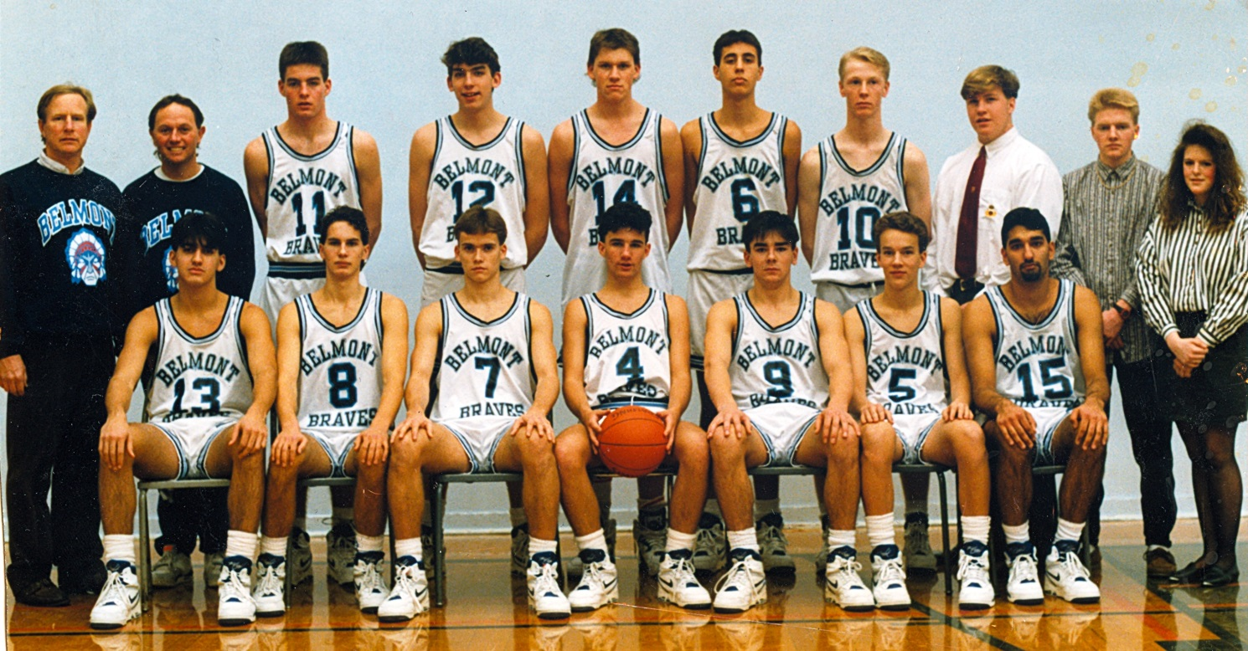
The 1991 bronze medal Belmont Braves basketball team. Amrit is #13 on the far left in the front row.

