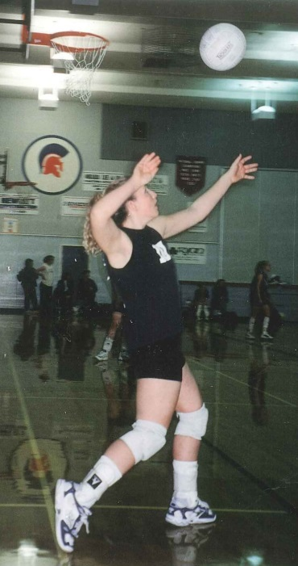
Andrea Gollmer: 2000-2002

Andrea Gollmer was the standout setter for the Belmont girls’ volleyball team that won the provincial championship tournament in 2001-02. This was the second BC title in three years for the Gollmer family, as her older brother Ben achieved the same feat in 1998 with the Belmont boys’ team.

Andrea first started playing volleyball in grade 5 at Willway Elementary School. Basketball was originally her sport of choice, as she played on the Willway team as well as a night league squad when she was 10, but the following year Ben started getting serious about volleyball and he began to teach the basic skills to his little sister. Andrea attended Coach Mike Toakley's summer volleyball camps at Cedar Hill Recreation Center starting at age 11, and by grade 8, started to play the sport competitively, both with her Spencer and Victoria Club teams. She also competed on the B.C. Summer Games team in 2000.

The highlight of Andrea’s volleyball career was winning the AAAA provincial championships (at Capilano College over a very strong North Peace team), and being selected as a first string all-star in the championship tournament. This meant a lot to her for a number of reasons. First, she wanted to make her brother, family and Mr. Toakley proud. Her brother's team (also coached by Mike Toakley) was the first Belmont team in 50 years to win a provincial championship, and the 2002 girls’ team was the second. Andrea and the Belmont girls had almost done it in 2001 when they made it all the way to the final of the B.C.’s before having to settle for silver. After the big win in ’02, she decided not to play club ball that year and realized that the BC’s were most likely her last real competitive tournament.

Although she says it might sound odd, Andrea’s best Belmont sports memory didn’t involve her own impressive accomplishments, but instead was having the opportunity to watch her brother and his Belmont teammates win the Provincials in 1998. She recalls “it was such an intense game, the rules were different then, it was before rally point came into play so you had to be the team serving in order to get a point. That made for much longer games. It went to the fifth and final match and it was a nail biter all the way to the end. I think it ended somewhere around 1:00 in the morning, it was a long and exciting match and I was so happy I was there to see it in person as those were the guys I looked up to.” Andrea also credits Ben, along with his good friend and team-mate Darren Goss, for being the most positive influences upon her volleyball development. She looked up to both boys and greatly appreciates the fact that they were so encouraging and invited a girl who was three and four years younger than them to tag along to their practice sessions and included her in their drills and recreational games. In her words: “That is what really what made me into the player I became and where my love for the sport began. I went to all of Ben's games along with my mom and grandma, and we would go on road trips on the weekends to watch his tournaments. I loved it. It was inspiring.”

Andrea stopped playing competitively after high school, but she has always maintained her love of the sport. Whenever she travels, she always carried a volleyball in her car and has found it to be a great way to meet new people. Andrea plans to pass on the love of the game to her own children and to keep the fun of backyard volleyball alive. Maybe she’ll even coach a school team one day.

Her advice to current Belmont students is to “Be competitive but humble; have goals and strive for greatness, but always remember that sports should be fun.”

