Ben Gollmer: 1997-1999
Ben Gollmer came to Belmont from Spencer and attended the high school for his grade 11 and 12 years. He was a single-sport athlete who excelled in volleyball and helped lead Belmont to its first ever provincial championship in 1998-99.
Baseball was the first organized sport he played as a youngster, and he didn’t get introduced to volleyball until elementary school at the age of 11. At Spencer Junior High School, he first met his coach Mike Toakley, who would help Ben and his team-mates progress to an elite level. In the fall of 1996, Ben’s grade 10 year, the Spencer squad captured the provincial championship, with Ben as their setter. That same year, Ben played club volleyball for the Victoria Fever, who had an amazing season, winning both the provincial title and then the U-16 National Championships.
Most of Ben’s Spencer team formed the nucleus of the Belmont 1998-99 B.C. championship team. This group experienced a dominating senior season. The boys won all six major tournaments they played, and Ben received first team all star awards in five of those tournaments and the MVP award at the other. Although he has many positive memories of his time at Belmont, the best moment was winning the AAA provincial title by defeating arch rival Claremont 18-16 in the fifth game of the best of five championship game in front of a packed gymnasium in Kelowna.
Ben continued his impressive volleyball career after high school graduation. He was selected to Team BC and first travelled to New Orleans to compete in the Junior Olympics, and later participated in the Western Canada Summer Games in Prince Albert, Saskatchewan. He then played two seasons with the Camosun College Chargers, and helped the team rise to as high as #3 in the country at one point.
There were many people that assisted Ben in achieving his high level of performance, including his Team BC coaches and team-mates, but he credits his Spencer and Belmont coach Mike Toakley, as having the most positive influence upon his volleyball career. Coach Toakley recalls that Ben “had a kind of quiet, but intense, leadership style. He was a serious student of the game”. Today Ben still participates in recreational volleyball, mostly in grass leagues and beach, but no longer has serious competitive goals in the sport. His advice to current Belmont athletes is to set goals and work hard every day to achieve them. He adds that it takes a major commitment to be successful in any sport, but it is extremely rewarding when that hard work pays off.
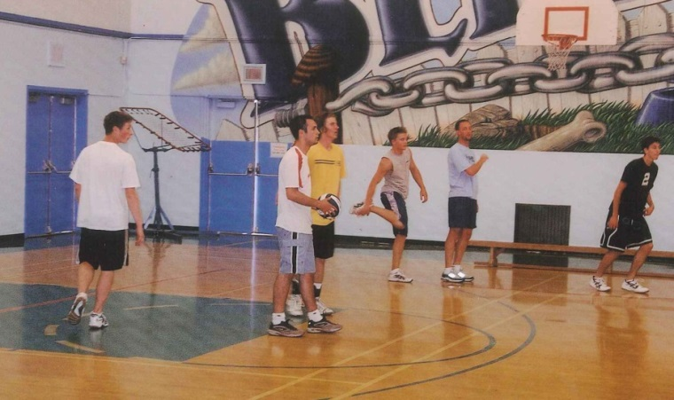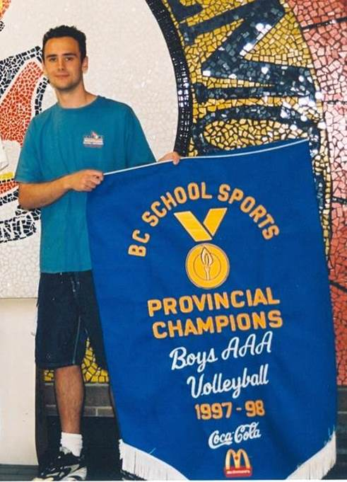
Left: Ben with his grade 10 Spencer team-mates Right: Ben holding the 1998 championship banner

