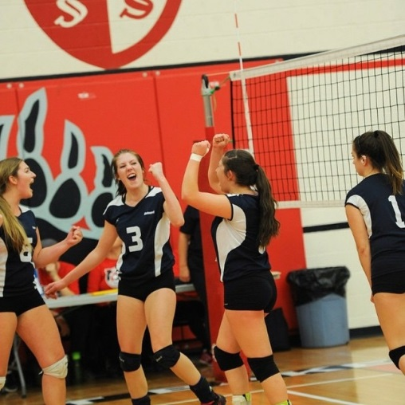
Cassy Allen

Cassy was a valuable contributor to Belmont’s athletic program the past three years. As a youngster, soccer was her first sport, and her father coached her community team in Prince George throughout elementary school. However, after an embarrassing fall in the mud, she decided to stick to the indoor games of volleyball and basketball. She made an immediate impact upon Belmont’s athletic program her grade 10 year, and was one of the strongest players on the junior girls’ volleyball team that finished first on the Lower Island and advanced to the provincial tournament. She was also a defensive standout with the junior girls’ basketball team that finished fourth on the Island.

After an intense season of club volleyball with the powerful Victoria Titans squad that finished second in the country at the national U-17 tournament, Cassy assumed a leadership role on the Belmont team her grade 12 year. She captained the team to a second place finish in the Vancouver Island tournament and a berth at the BC’s, and was named a first team Island All Star. In basketball, she was the 2nd leading rebounder on the team and helped them achieve a fourth place finish on the Island. For her outstanding athletic accomplishments in 2014-15, Cassy was named co-winner of Belmont’s Top Grade 12 Athlete Award.

Although the wins were great, Cassy says her best Belmont sporting memories were the road trips and all the fun times shared with team-mates. Next year she plans to attend Camosun College and will play volleyball for the Chargers’ women’s team that won the bronze medals at the 2015 Canadian College Championship Tournament.

When asked about her experience with the sports history project, Cassy stated: “I really liked talking on the phone to the Hall of Fame athletes and hearing their stories, especially the volleyball ones. So many of them went on to play at a high level after Belmont, which I never knew before.”

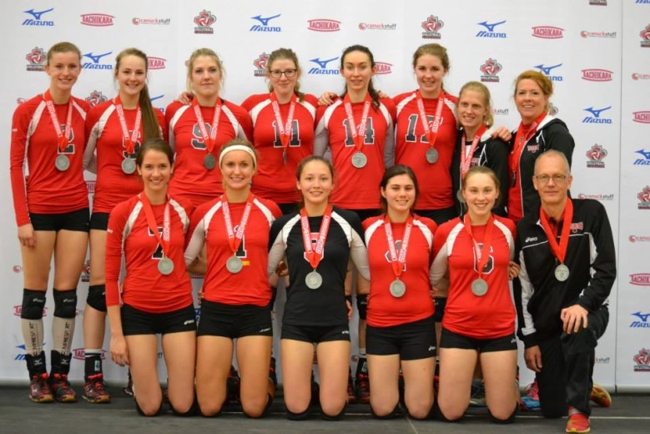
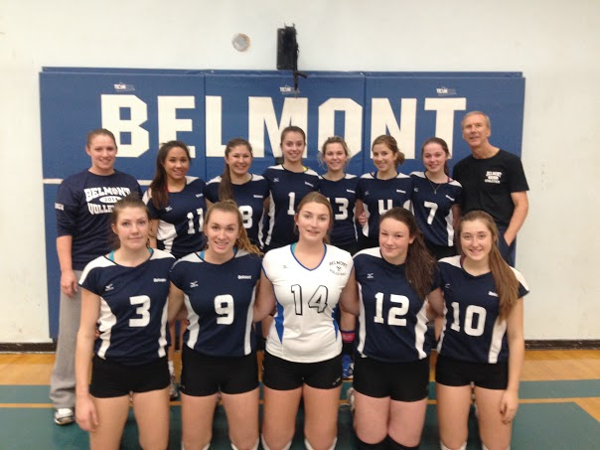

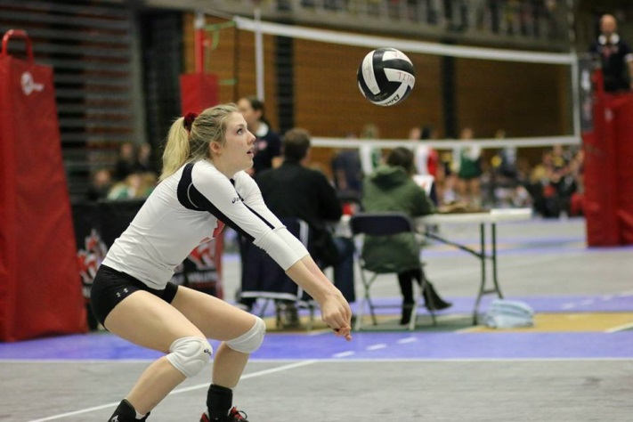
Cassy focuses as she prepares to receive serve
Cassy is in the back row 3rd from the left with the silver medalist Victoria Titans
Cassy (#3) with her 2014-15 Belmont team

