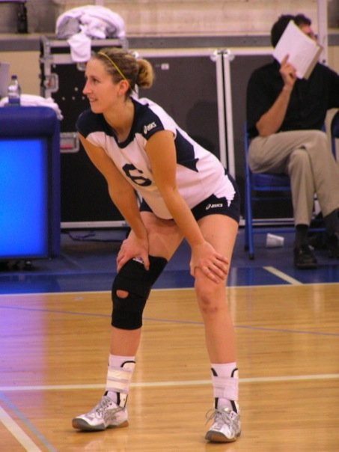
Danielle Petersen: 2001-2004
Danielle was one of Belmont’s talented female volleyball players of the 2000’s, who went on to achieve a high level of success at the collegiate level. She first became involved in athletics at a young age as a way to establish her own identity in a different field than her highly scholastic older sister, but soon discovered its own intrinsic value: “I loved the physicality of sport, I loved the pressure and adrenaline, I loved finding the balance between mental calmness and great physical energy. I loved the beauty of how the human body could perform.” Besides volleyball and track and field, Danielle was also heavily involved with the Martial Arts discipline of Shotokan Karate and earned her black belt at the age of 17.
Although extremely competitive on the court, Danielle was also a free spirit in high school, so it’s not surprising that her best Belmont sporting achievements are specific moments rather than external accomplishments. For example, she is glad that she competed in sports in which she was relatively average, such as the high jump. As she explains: “It is easier to do things that we are good at. I am proud that I did things I was afraid of and sport was an avenue that I used to do that.” She recalls having lots of fun with her team-mates and developing strong bonds, particularly at the out-of-town tournaments. She describes her group as “quite goofy” and remembers doing silly things together, such as the time the rookies all wore diapers to their first home game and looked so absurd she couldn’t stop laughing.
After high school, Danielle accepted a scholarship to UBC, where she a “sisterhood” developed between the players. As she says, for five years she spent every day with her best friends. She was part of a strong team that consistently contended for the national championship, but it wasn’t until her fourth year, that the girls won the ultimate title: the first time in 30 years that the Thunderbirds had won a gold medal in women’s volleyball. She describes the experience eloquently: ”We had just come off a rebuilding year and we were not expected to place, but our team had such tenacity, heart, vision and plain grit that we managed again and again to beat our competition. The championship final went all the way to five games. In volleyball the game ends at 25 but you have to win by 2 points. The team were so close each sets was going into the 30s, which is rare. The tie breaking set to 15 had many amazing moments where everyone was doing their job, making digs, setting up plays. Time started going slow motion. When we won the final point the euphoria was overwhelming. As a team we managed to accomplish our goal, but did so with gumption and as a unit. The synergy and dynamic energy that team accomplished together has been a unique experience in my life. The following year I was captain of the team when we won gold again. That was the start of a long legacy of championships at UBC.”
Danielle credits UBC coach Doug Reimer and Belmont coach Mike Toakley as being important contributors to her success. Both men really emphasized respect and cared about the development of both the athlete and the person. She feels that she was supported with emotional reinforcement and was critiqued on her performance with technical advice, which helped her to achieve her potential as an athlete.
Although no longer competing in high performance sport, Danielle coaches volleyball and plays in local adult tournament, and also still gets in the ring to spar on weekends. When asked what advice she’d offer to aspiring young Belmont athletes, she replied: “ FAIL...and be proud of it. I know it sounds odd, but I deeply believe athletes (and everyone for that matter) must establish a new relationship to failure. Nobody is successful right away, or all the time or in all things. I remember I was often so afraid of making a mistake that it hindered my performance. Learning to be okay with failure and mistakes and even developing a relationship with these aspects of the self is perhaps one of the most important and worthy challenges to pursue.”

