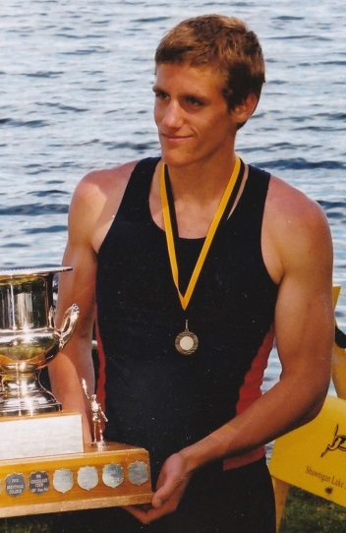
Danny Buchanan: 2003-2006
As a young child, Danny Buchanan was very active and participated in cross country and swimming. In grades 6-8, he played soccer in the Juan de Fuca association. When he attended Belmont from 2003-2006, he played a little bit of rugby, but most importantly, joined the school’s rowing team. Rowing would be the sport in which he would truly excel and would propel him to national prominence. Under the guidance of coach Sonja Leverkus, Danny quickly developed into one of the top young rowers in the province. In grade 10, his first year of formal competition, he and partner Keith Siklenka qualified for the Canadian Secondary School Rowing Association Championships in St. Catherine’s Ontario in June, 2004. The Belmont duo capped off their impressive season by capturing the gold medals in the doubles event. The boys competed in the national championship again in grade 12 and took home the silver medals in the pairs. Danny was also a member of the BC crew that captured gold at the 2005 Canada Games in the eights.
Danny continued to row at the post-secondary level. His experiences in the sport helped him gain the self-confidence to believe he could achieve his dreams if he was willing to do the work. His coach, Sonja Leverkus also inspired him to be a better athlete, playing a significant role in Danny’s life all throughout his rowing career. Danny describes her as an exceptional woman with an inspiring work ethic and love of life.
To this day, sports continue to be a part of Danny’s life. He has just recently started a recreational soccer league, plays Frisbee golf and goes to a fitness boot camp regularly. This is his advice to any students who wish to pursue a sport after high school: “Enjoy it, and think about it in the big picture. In the end, competition in sports can only offer a fleeting victory. How will your time in sport help you and or others in the future? If you sacrifice your future to win today, you will lose in the long run.”
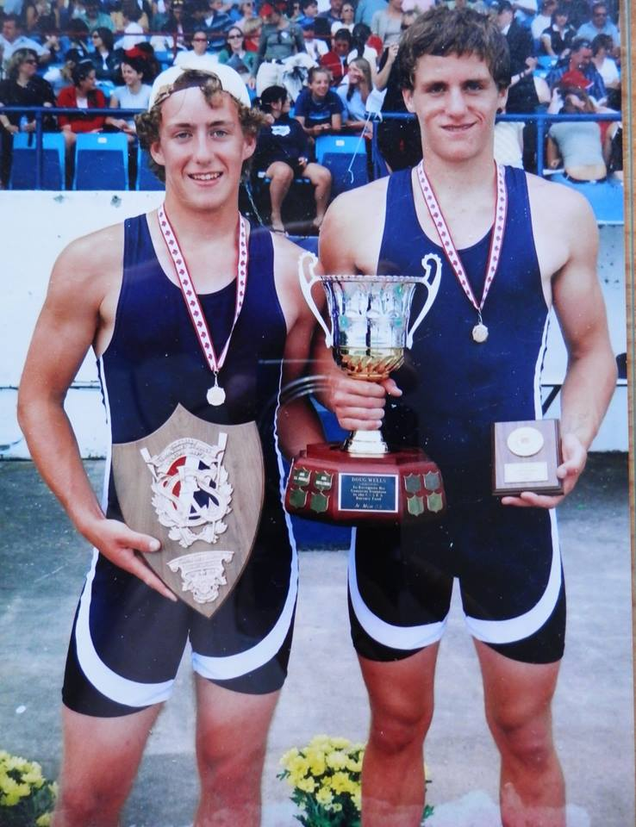
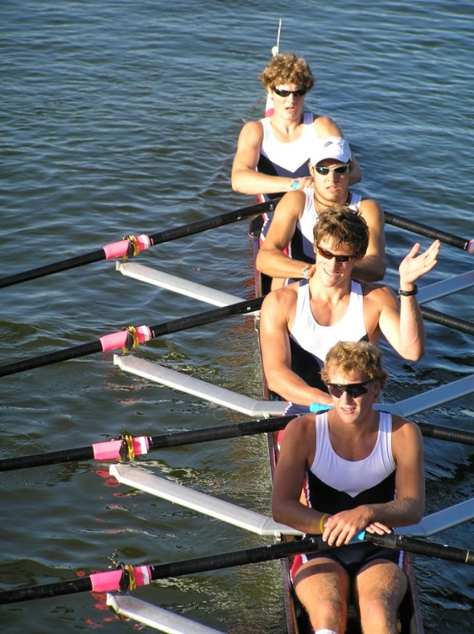
Danny waves after winning the bronze medal with his three team-mates at the 2005 Canada Games
Danny (on the right) and partner Keith Siklenka display their trophies after winning the Canadian pairs championship in 2004

