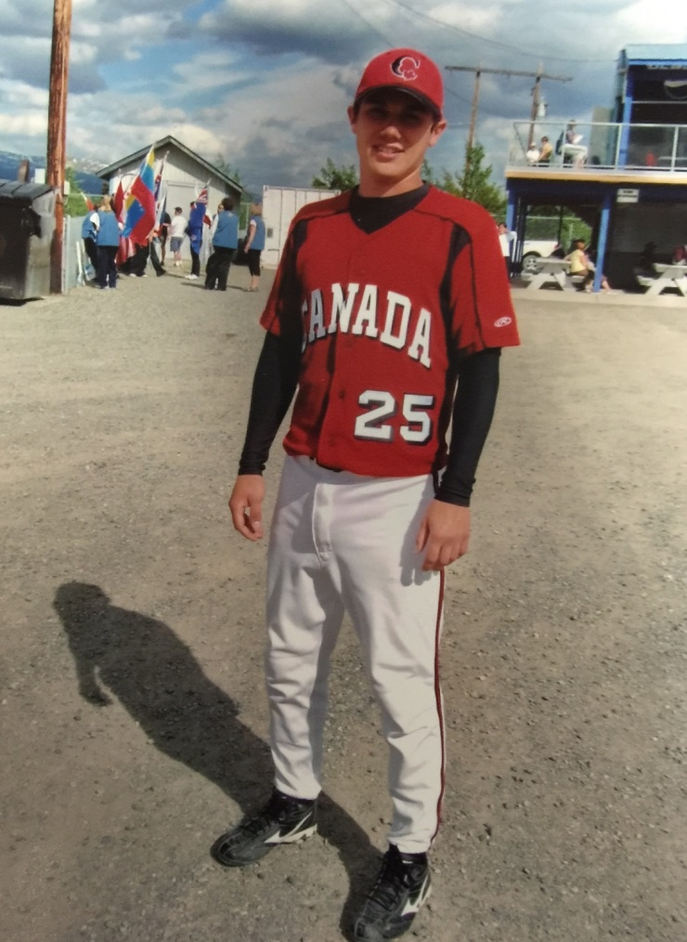
Darcy Walushka: 2005-2008
Darcy Walushka, nicknamed “Wally” by his team-mates, attended Belmont Secondary School for his grade 10-12 years. He was an all-round natural athlete, but due to his older brother and sister’s love of fastball, Darcy focused on that sport as well, and signed up for Langford Minor fastball at the age of five.
During his years at Belmont, he played grade 10 basketball and volleyball. Although not very tall, he was extremely quick and agile, and was known for acrobatically diving after loose balls in volleyball games and playing tenacious defence in basketball. Darcy says his best Belmont sports-related memory was being the number one cheerleader for the senior boys’ basketball games in grade 11 and 12. With his high energy level and great school spirit, he was always able to get the crowd hyped up and get the gym rocking, which made it a tough atmosphere for opposing teams.
Darcy continued to focus on fastball during his high school years, and that sport provided him with his top sporting accomplishments. In 2007, as a member of the Sooke Smoke, he won the Midget Boys Fastpitch National Championship and was named to the tournament All- Star team. One year later, Darcy was selected to the junior men’s Canadian National fastball team and was part of the group that won the silver medals at the Junior Men’s World Championships! As evidence of Darcy’s superstitious nature, he always put his left sock on first, and even occasionally slept with his bat if he was having trouble hitting the ball.
Overall, sports helped Darcy mature as a young man and made him realize that no matter how talented one person is, they can’t succeed without the help of teammates, coaches and fans. Teams win together and lose together. Darcy considers his older siblings Kris and Shelley to be his most positive influences because they always pushed him to get better at what he did. They also always supported him whenever they could.
Darcy’s advice to current Belmont student-athletes today is to “be confident, not arrogant. Believe in yourself and your teammates, and you will be successful. You got to believe it, to achieve it.”

