Della Smith Gwin: 1973-1978
Della Smith was an outstanding multi-sport athlete who anchored many of Belmont teams during the mid 1970’s. She started in grade 8 at Elizabeth Fisher Junior High and was in grade 9 when the two schools combined into one huge 8-12 facility. She participated in field hockey, volleyball, soccer, swimming and track and field. Ironically, despite all those teams on her Belmont resume, her best sport was probably softball, which was not even offered at Belmont in the 1970’s.
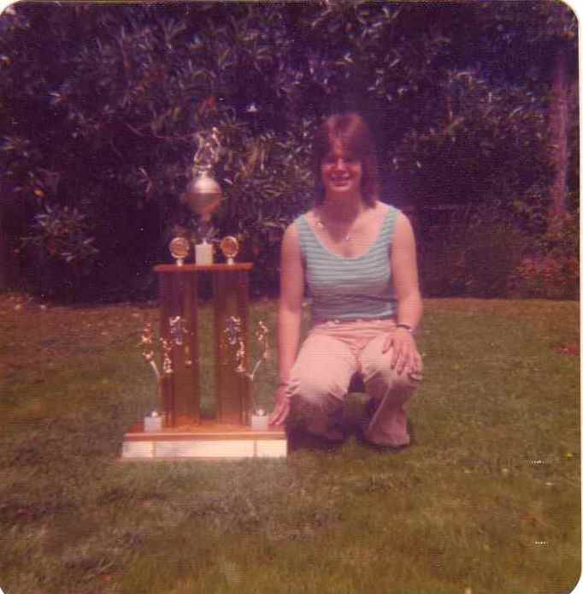
Athletic excellence was part of the Smith family history, as Della’s mom Shirley and aunt Marylin (Babe) were softball and volleyball standouts from the 1950’s, and are both Belmont Hall of Fame athletes. Sisters Kristy and Jennifer also played the sport at a high level. Della recalls starting softball in grade 5 or 6 at Savory School, while her first community team was with Langford in the Colwood and District Softball Association. Andre De Hoog, a teacher from Glen Lake School and future principal in the district, was her first coach. She and her sister Kristy played on the same team all the way through to the Victoria Saanich women’s league at Hyacinth Park. It was at Savory School where she received her introduction to soccer, and was delighted when the sport opened up for high school girls during her grade 10 year at Belmont. She continued to play soccer as an adult: first for Gorge, then with Juan de Fuca, and finally ending up with Vic West, where she anchored the defence from 1982-2005.
Della accumulated a number of awards at Belmont, including the most inspirational athlete in grade 10 and the outstanding female athlete in grade 12. Her coaches remember her as a talented, highly competitive, and lots of fun to be around.
Della poses with her grade 10 most inspirational athlete trophy in 1976.

Athletics continued to play an important role in Della’s life as an adult. She played fastball in the Victoria Saanich league from 1979-2005 and won two league batting titles. Her teams competed in a number of Senior B Western Canadian Championships, and in 1988 in Yellowknife, she was selected as the all star shortstop. She also competed in softball at three World Masters’ Games, and even played soccer as well at the 2005 World Masters’ in Edmonton. The 1998 Games in Portland, Oregon, were particularly special, as she shared the experience with both sisters, Kristy and Jennifer. In Melbourne, Australia in 2005, Jennifer was on the team again, but they had lost their sister Kristy to cancer in 1999. In an emotional moment, mom Shirley literally “stepped up to the plate” in her daughter’s honour and was awarded a silver medal with the rest of the team.

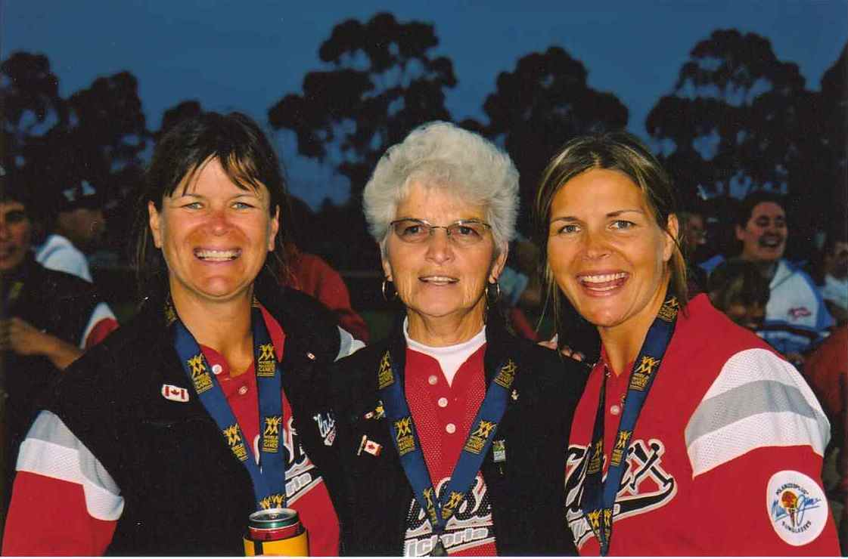
Dellas credits a number of people for helping her to achieve athletic success over the years. Her high school volleyball coach Patti O’Neill, (AKA “Rowdy”) particularly stood out at Belmont, and Della would later play softball with Patti’s daughter Erin. Her close friend Lisa Hayton, a team-mate on the ball field and the soccer pitch, was a positive influence, and of course her family: mom Shirley, dad Vern, and sisters Kristy and Jennifer all provided inspiration and support.
Della, Shirley and Jennifer wearing their silver medals from the 2005 Melbourne World Masters’ Games

