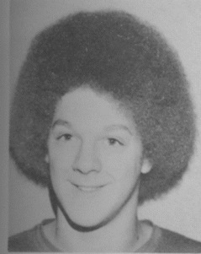
Doug Portelance: 1971-1976
Doug Portelance always had a love for water, and found his sport at the age of nine when he joined a local swim team, the Juan de Fuca Cohos. When he first started swimming, he only knew how to do the backstroke, and this soon became his best stroke. Growing up, Doug’s father was his inspiration, competing in two British Empire Games, and bringing home a silver medal in the mile from the Auckland, New Zealand Games. His father also swam on scholarship for the University of Washington in Seattle. Doug attended Belmont from grade eight to twelve, swimming for both the school and Juan de Fuca until he graduated.
During his junior year at Belmont, Doug competed at the Provincial High School Championship and won the 50 backstroke. In his senior year, he went to the provincial championship again, but this time he won the 100 backstroke. That year, he also competed at Canadian Nationals and then at the Canadian Olympic Trials held in Toronto in 1976. He finished 13th in the 100 backstroke and 15th in the 200 backstroke at the Trials.
After high school, Doug, along with his brother, swam for the University of Washington for four years, where he attended college and medical school. He also competed in the 1980 Canadian Olympic Trials, finishing 10th in the 200 backstroke. To this day, swimming continues to be a part of his life. He competes in many open water swimming events, swims with a local masters swimming team and swims workouts with his friends. He also helps coach his daughter’s Special Olympics swim team, and spent many years following his son’s swimming career from age seven through college at Tufts University in Boston. For Doug, swimming gave him opportunities to travel and he considers it a great lifelong fitness activity as well as a wonderful family experience.
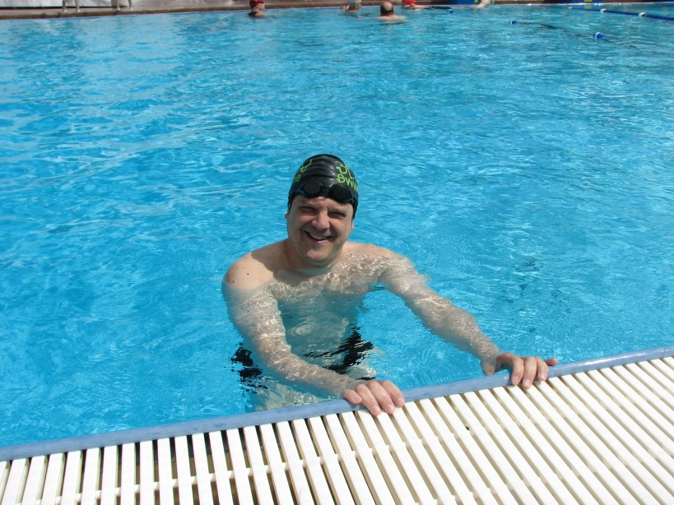
Doug at a swim meet a few years ago.

