Glenn Willing: 1960-66
Glenn Willing was an all-round athlete who attended Belmont from 1960-66. He played every sport possible, including basketball, volleyball, cross country and track and field and was named the senior boys’ top athlete in 1965 as a grade 11. He feels that distance running was probably his best athletic skill and he takes pride in the fact that he won the Glen Lake run an incredible 5/6 years he was at the school. This race was a prestigious event that served as the school’s official cross country championship and competition was always fierce. After Glenn earned his 5th victory, the PE teachers decided to give him the trophy as a permanent memento, and he still has it at home today!
As well as the inter-school competitions, Glenn has fond memories of intramural sports at Belmont. He especially enjoyed the intense floor hockey games that he and his friends played at lunch and after school. His favorite teacher was Mr. Teagle, who often joined in the games and added a competitive spirit. He recalls that his group of friends just loved the chance to compete in whatever sport was offered, and would play at lunch and after school for as long as they were permitted.
Sports continued to play an important role in Glenn’s life as an adult and he remains fit and active today. He still competes in softball at the master’s level, and has participated in the World Masters games. Although it has been almost fifty years since Glenn graduated from Belmont, he is still extremely loyal to the school and is eager to see its traditions preserved. The Willing family connection continues at Belmont today, as son Brian, a strong rower and recipient of the senior boys’ sportsmanship award in 1994, currently teaches science at the school.
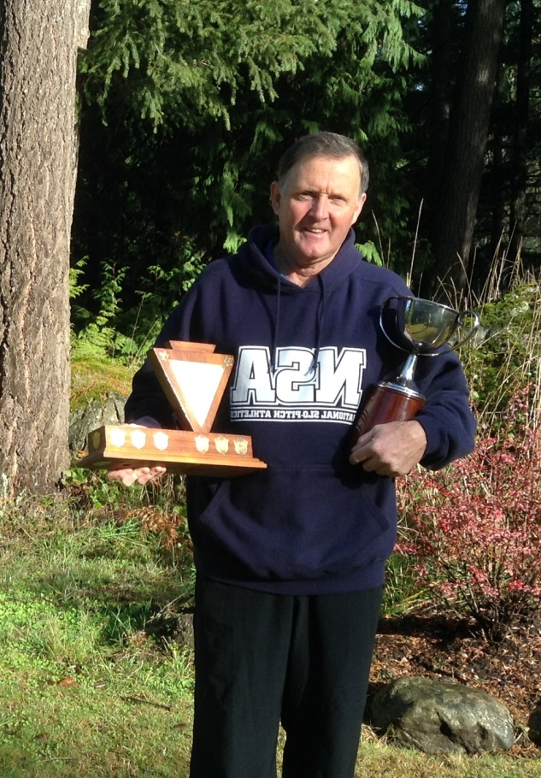
Glenn was featured in the Colonist newspaper after he captured first place in the 1967 “Miles for Millions” 25 mile race at the age of 19.
Glen shows off the Glen Lake Run trophies

