Hannah Allen

Hannah is a natural athlete who played a number of sports, including soccer, basketball and track and field while growing up in Prince George. After moving to Victoria in grade 6, she focused primarily upon basketball, and was a key contributor to Belmont’s teams the past three seasons as one of the top rebounders and scorers. Hannah’s strong leadership skills, outgoing personality and ability to relate to others led to her selection as captain of the junior girls’ basketball team in grade 10 and the senior team in grade 12. Despite battling through a staggering number of injuries in grade 11 and 12, including a serious concussion, cracked patella, dislocated thumb, broken foot, dislocated finger and cracked ribs, she persevered and kept defying the odds by returning to action. In both her grade 10 and 12 seasons, the Belmont squad finished fourth on the Island and came within two points of qualifying for the challenge game to go to the BC’s.

Although Hannah enjoyed all three years of Belmont basketball, her best sporting memories come from her grade 10 season,which she describes as “the most amazing year ever!” She has started coaching basketball with the Westshore Rain junior program and is a natural with the younger children.

Hannah coordinated the visual component of the Belmont Sports History website and produced the power points for each decade, as well as the sporting families photo gallery. When asked about her experience with this project, Hannah explained: “I found it really interesting to learn about the older athletes. You can flip through the yearbooks to find out a little bit of information, but when you talk to them in person, you learn much we have in common with them. It’s really cool to discover all the connections through Belmont and the Westshore.”

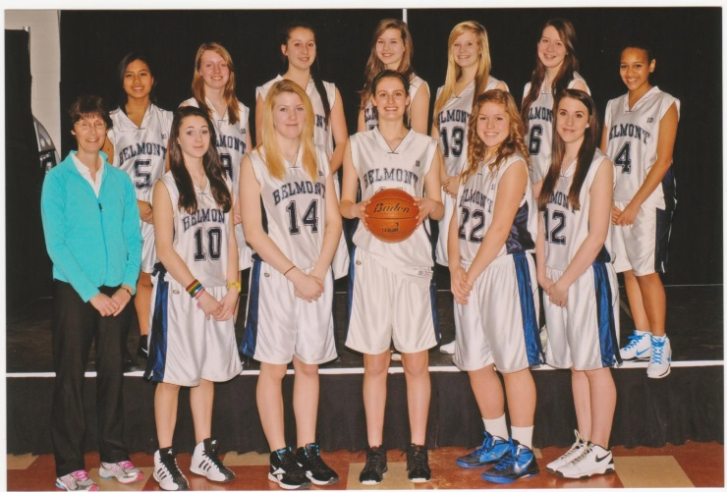
Hannah (12 in the front row) with her grade 10 basketball team.
Hannah and her grade 12 team-mates after qualifying for the Island tournament.

