Jan Nowell (1972-74)
Jan, a multi-sport star, attended the Belmont from 1972 to 1974 and played basketball, volleyball, grass hockey, and badminton. Her many athletic accomplishments led to her being selected for Belmont’s top female athlete trophy in both 1973 and 1974. She also received numerous individual awards in basketball, including team MVP, and All Star recognition for two consecutive years in the Towhette Tournament. Her favourite sports memory was when the girls’ basketball team was playing a game up in Duncan. There was 7 seconds left in the game and the Tomahawks were down by 2 points. Jan scored the basket to tie up the game and was fouled on the way to the basket. She calmly scored another point at the free throw line to win the game. But her absolute best memories are the ones she shared with her team mates; she remembers lots of laughter and good times.
Jan also played on several volleyball, basketball and softball teams after high school graduation. In the summer of 1974 she travelled to Europe with a volleyball team called the B.C. Islanders. They played the England National team and several teams in Germany which was a great experience. Then she went on to play with the UVic Vikettes women's basketball team in 1974/75 and 76/77. Her team went undefeated in league play, winning 20 straight league games: a feat never before accomplished in the Canada West league. That year they went on to the Nationals in Guelph, Ontario but lost one game which denied them a chance at the Canadian title.
Jan, also known as “Janner” to many of her team-mates, claims there were many people and teachers that made a difference in her athletic career but “the ones that made a really difference were Mrs. Pam Henson, Mrs. Marta Vaesen, and Mrs. Gail Robb, all wonderful people dedicated to their jobs and helping young people. Many thanks to them.”
Jan’s advice to future Belmont athletes is: “Learn the fundamentals, practice hard and have fun.”
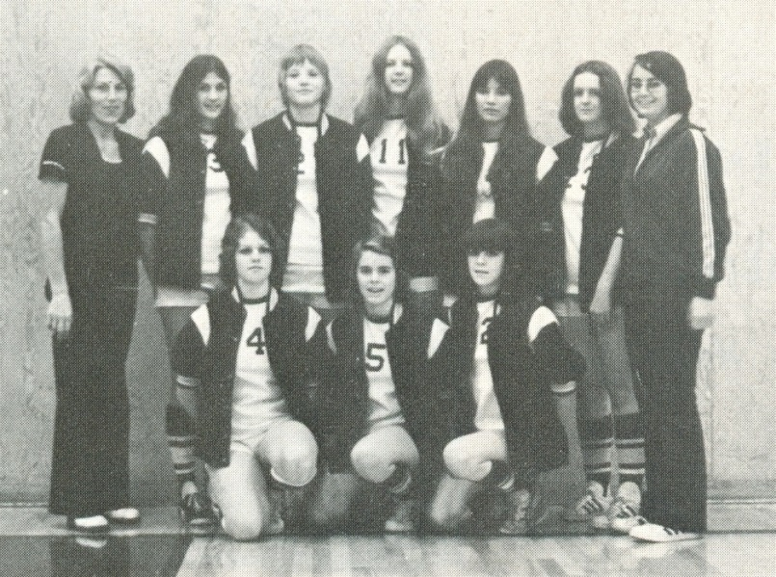
Jan with her 1973-74 girls’ volleyball team. She is standing in the back row, third from the left.

