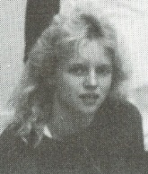
Janice Halls: 1986-1988

Janice Halls was a gifted multi-sport athlete who showed off her versatility by starring in six different sports at Belmont: basketball, volleyball, soccer, cross country, field hockey and track and field. As talented she was at the preceding six sports, softball was perhaps her #1 game, but it wasn’t offered in high school at that time.

Many players consider themselves fortunate to make it to one provincial championship during their high school career, but Janice made it regular occurrence, qualifying for the BC’s in soccer, basketball and cross country. She was starting point guard on the 1987-88 Tomahawks basketball team and was named the outstanding defensive player at the BC High School Championship Tournament. In soccer, she was one of the leading scorers and helped the team capture city and Island titles, and come up just short of the medals with a 4th place result at the BC’s. Her efforts didn’t go unrecognized, as she was named Belmont’s top grade 11 female athlete in 1986-87, and shared the outstanding senior athlete trophy the following season with her good friend and team-mate Dana Kinghorn. Although the personal accolades were appreciated, Janice says her best Belmont sporting memory was a road trip to Edmonton with the boys’ and girls’ basketball teams. Janice felt that Belmont teacher and coach Diane Savoie played a major role in her development as an athlete, particularly when she was a grade 8 athlete who played up on the senior teams. Her parents were also highly supportive and attended all her sporting activities.

After high school graduation, Janice continued to play basketball in college and then went on to play softball at SFU. She also won two national championships with the White Rocks Renegades community softball team. Janice demonstrated her determination and perseverance by trying out for Team Canada for 18 years and being cut every year! Her proudest moment as an athlete came when she was selected to Canada’s national women’s baseball team and finally got to put a Canadian jersey on her back when the team travelled to Cuba in 2004.

Now that Janice is older, she continues to be a learner of the game. She still plays baseball on a women’s travelling tournament team out of the USA and also plays hockey. She says that her “skills have changed and I'm no longer quick or agile but I've learned to develop the mental part of the game and as a coach now, try to instill the important parts of the game like sportsmanship, work ethic, and loving the process - not the outcome.” When asked if she has any advice for current Belmont high school athletes, she replied, “If you love the sport, and practice hard at knowing the process of the skill, the outcome will be there.”

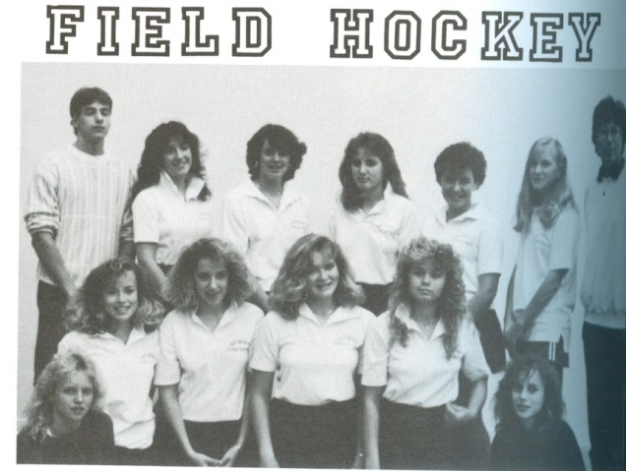

Janice is kneeling in the front row on the far left with her 1988 field hockey team.

