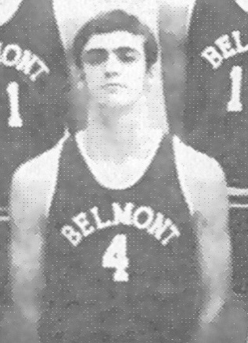
Jim Kupiak: 1970-1972
Jim, known as “Kup” to his teammates, was an outstanding basketball player who helped the 1971 and 1972 teams develop into legitimate contenders for the provincial title. He played baseball in the community, but basketball and soccer were the two sports he played at Belmont.
Jim considers his best Belmont sporting accomplishment to be winning the bronze medals at the 1972 Triple AAA high school basketball championship and having the team win the most sportsmanlike award. Belmont was only a Double AA school based on their population but elected to challenge themselves at the highest level of competition. Jim was recognized for his outstanding individual play by being selected to the tournament first all star team.
Athletics continued to play a major role in Jim’s life after graduation and he was invited to try out for Canada’s national basketball team! He also coached a variety of teams, including hockey and basketball. He says that his greatest gratification as a coach came in ice hockey when he was head coach for his son’s bantam team and they won a Mid Island league and playoff championship.
Jim credits two coaches for being instrumental to his life’s successes: “Both Wally Russell, senior coach, and Bill Spotswood , junior high coach, taught that with hard work and preparation you can achieve things that you did not think you were capable of. I tip my hat to both men to thank them for their time and effort in providing us with so many life skills.” He also pays tribute to his parents: “My mother and father were my earliest supporters as they coached and assisted with all the teams I and my brothers played on. At least one if not both attended each and every game we ever played in.” Finally, he acknowledges his Belmont Braves teammate: “And last but not least my best friend and fellow athlete Jack Munch who made me a better player by practising every day against one another.”
Jim advises current Belmont athletes to “Work hard and take advantage of the opportunity that you will have individually or as a team. The friendships you develop will be for a lifetime.”
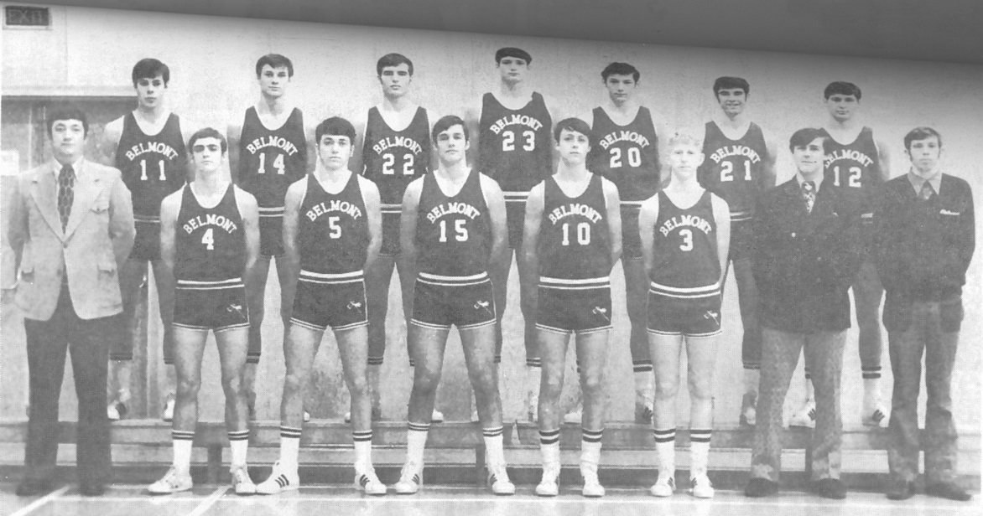
The 1971-72 Belmont Braves basketball team that finished 3rd in BC. Jim Kupiak is #4 in the front row and his close friend Jack Munch is # 15.

