John Batcheller 1958
John Batcheller was recognized at Belmont as a talented athlete and an inspirational leader. John moved to Victoria from Edmonton at the end of the 9th grade. He excelled at basketball and was the captain and a star player of the Braves team in the mid 1950’s. He was also a member of Belmont’s fine track and field team, led by Chris Gardner, placing well in the 100, 220 & 440 yard sprints, and was a strong softball and soccer player. He also took on the job of coaching the Senior Girls basketball team, led by Babe Moseley,Georgette Peden, and Sheilla Arden to a high placing in Greater Victoria.
One of John’s favourite memories was going to the Vancouver lsland Basketball Championship, where the team placed 6th and he was selected as a tournament all star. This was the best result for a Belmont team in the school’s young history. He is also remembered by some of his classmates for an unusual car accident that involved three cows along Jacklin Road.
After high school graduation, athletics continued to play a major role in John’s life, first at college and later playing for the Osler Street Athletic Club. He appreciates the many life long friends he made through his association with sports.
When asked what advice he would give to current Belmont athletes, John responded “to always keep trying and never give up.”

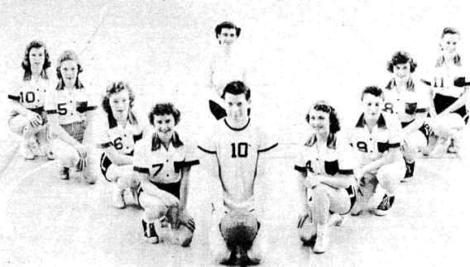
John coached the 1956 Girls’ Basketball team at Belmont while he was still a student. # 10 was always his number.

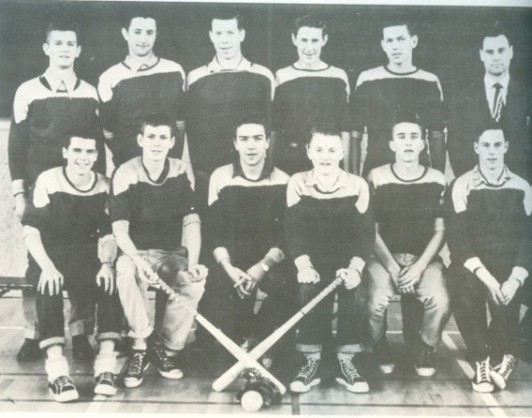
John is third from the left in the back row with his 1955-56 Belmont softball team-mates.

