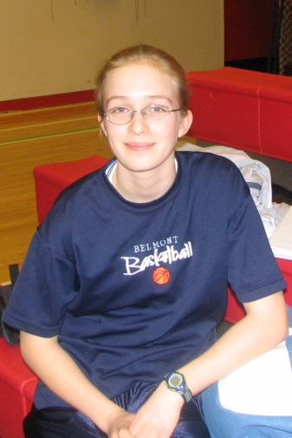
Julia Tschanz: 2004-2007
Julia was an extremely dedicated and hard-working athlete who exceeded many people’s expectations for her. Her parents encouraged her participation in sports from a young age and she competed in cross country, and basketball from elementary school through grade 12. At Belmont, even though she sometimes longed to be a star player, she was more of a supporting player who was integral to the success of the team. In basketball, she was a member of the Belmont junior girls’ team that placed 2nd on Vancouver Island and qualified for the provincial tournament, and in cross country, she was part of a small contingent who consistently challenged the top teams in the city. Julia’s high school coaches all considered her an absolute delight to have on a team, as she always gave 100% effort and was totally supportive of team-mates. In her quiet, unassuming manner, she was an outstanding role model who played sports for all the right reasons. In grade 10 she won the top junior sportsmanship award and earned the same honour at the senior level in grade 12.
Although Julia values her years on the basketball court, she believes her top high school accomplishment was finding her love of the track and racing at the BC championship meet. With the encouragement of teachers Dean Baldwin, who recognized her potential as a runner and Tiffany Evans, who became a mentor and role model to her, Julia discovered a talent she didn’t realize existed. After high school graduation, Tiffany strongly encouraged Julia to try out for the University of Victoria cross country and track teams, something Julia would not have had the self-confidence to do on her own. Not only did Julia make the team, she became one of their top performers, winning both individual and team accolades. Some of her highlights included being named Canada West cross country rookie of the year in 2008 and a Canada West all star on multiple occasions. She also won the Canada West women’s 1500 meter race in 2009, and one year later won bronze medals at the Canadian Interuniversity Sport Championships in the 1500m and 3000m, and broke the Uvic women’s record for the mile with a time of 4:47.55.
While proud of her racing accomplishments, Julia states that “the relationships I developed with my teammates and coach are incredibly important to me and remain the highlight of my University Career. Racing for the Vikes was the first time I felt innately good at something and this allowed me to grow into the person I am today. I am very grateful for the years I spent on the track and running in the woods. Now that I am not in school, I still run and occasionally compete on my own.”
She also gives credit to the many individuals who supported her. Her parents attended almost all her basketball games and still come out to her races. Her Uvic team-mates and coach Brent Fougner all encouraged her to draw out speeds she didn’t realize were possible, and her various Belmont coaches were also positive influences. She singles out Tiffany Evans, herself a former Uvic runner, as one of the strongest women she knows and someone who played a significant role in her success.
Julia’s advice for aspiring young Belmont athletes is to “surround yourself with positive and supportive people and reciprocate in support of others. Also, take every opportunity that comes your way while manufacturing your own future.”
