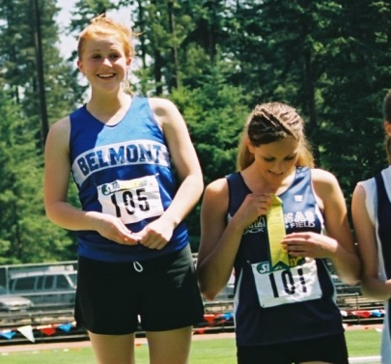
Kaitlin Huzzey: 2004-2007
Kaitlin Huzzey was an avid sports fan during her time at Belmont Secondary. Not only was she a member of the volleyball team, she also participated in cross-country as well as track and field. During her grade 11 and 12 years, Kaitlin participated in race walking at the BC High School championships. Her first year she came away with the silver medal, and her final year she won the race and became a provincial champion!
After high school, Kaitlin still managed to maintain an active lifestyle. She continues to enjoy running and will occasionally compete in a race for fun. She also began coaching for the Victoria Track and Field Club, an organization to which she has belonged since she was a child. Kaitlin considers Linda, her coach at the track club, to be one of her biggest supporters. She was at every one of Kaitlin's track meets and helped her a great deal through her high school career. Kaitlin also had tremendous support from her family. Her parents encouraged her to stay active while having fun. They would take her to every race and track meet, and they would attend every one of Kaitlin's volleyball games. Her sister and fellow Belmont Hall of Famer Megan, a standout race-walker herself, was also extremely supportive. Kaitlin loves having a sister who is interested in the same sports as her.
Kaitlin Huzzey truly enjoyed her high school athletic career. When asked to give advice for current Belmont athletes she said '' Have fun! Some of the best years of your life will be while you're in high school so enjoy it. Work hard, do your best, but don't put too much pressure on yourself to succeed. ''
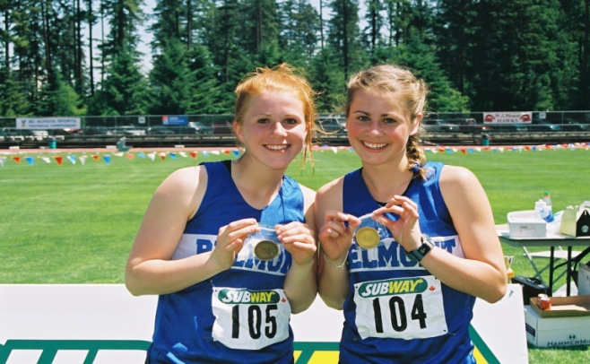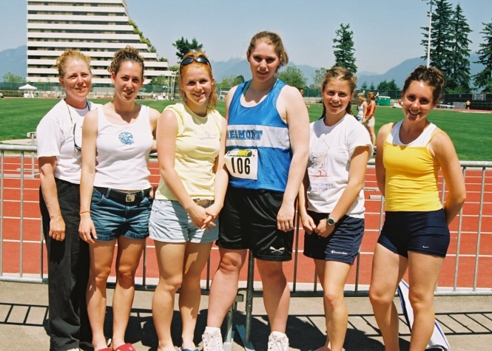
Kaitlin (3rd from left) relaxing at the BC’s with her track team-mates and Belmont coach Patti O’Neill
Kaitlin (left) and her sister Megan display their respective race-walk gold medals

