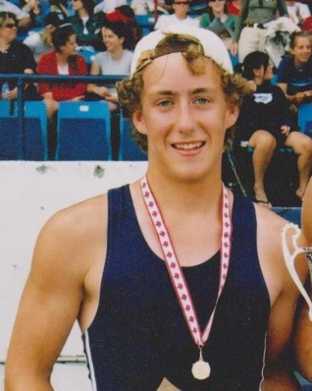
Keith Siklenka: 2003-2006

Keith Siklenka was an outstanding athlete who, along with his partner Danny Buchanan, captured a national title in rowing while still in grade 10! Keith was a natural athlete who grew up playing soccer with the Juan de Fuca association. He took up competitive rowing as a novice in grade 10 at Belmont, and within 9 months of serious training, had risen to become one of the top young rowers in the country.

Under the capable tutelage of coach Sonja Leverkus, Keith and his partner Danny Buchanan burst onto the local rowing scene and started winning regattas against much more experienced competitors from Brentwood College, SMUS and Shawnigan Lake. The two Belmont boys were close friends off the water, which contributed to their strong chemistry in the boat. Keith remembers they came up with the name “Bleda” for their boat, and when one of them called out that word during a race, it was the signal to start an all- out sprint for the end line. In 2004, Keith and Danny won the junior men’s doubles event at the provincial championship, which qualified them for the Canadian Secondary School National Championship in St. Catherines that July. The pair capped off their improbable season by capturing the gold medal in their feature event at nationals, and Keith took home the bronze in the singles race. One year later, Keith and Danny were both members of the “eights” boat that won gold at the Canada Games, and in their grade 12 year, they placed 2nd in the pairs event at the national championship race. Both boys earned tryouts to Canada’s national rowing team for their impressive accomplishments.
Keith credits coach Sonja Leverkus as a major player in his development as an athlete. “She was so patient (I'd imagine coaching grade 10 boys isn't easy), and taught us focus, goal setting and how to grow as athletes and people. In our first year of rowing Sonja took a chance with Danny and I after the Brentwood Regatta by offering to coach our double for nationals. How she saw potential in both of us was very influential to my athletic development.” He also would like to thank Lorraine and John Buchanan for all the rides to practice.

Athough Keith gave up rowing one year after high school graduation, he has remained involved in high-level sport and is now a competitive cyclist at McGill University, where he is completing a doctoral degree. Keith has moved up the cycling ranks and is now racing in Category 1 cycling events in Quebec. He has successfully balanced high level athletics and academics for over a decade, and certainly is well qualified to offer advice to aspiring Belmont athletes:
"I think that athletes should try and maintain their enjoyment in their sport and be careful of over-doing it. I see a lot of really successful junior athletes train hard for a few years, have a successful run, then lack motivation and drive to continue afterwards... They burn out. I think it's important to keep talented athletes in the pool of competitive sport for as long as we can, so we should focus on consistent, moderate training that stays fun. Try and find a great mentor or coach who truly understands your limits and pushes them gently. Finally, make sure to eat enough food! I have found that a plant-based, high carbohydrate lifestyle has been very effective at increasing my performance over the years. Get the carbs in for the win."

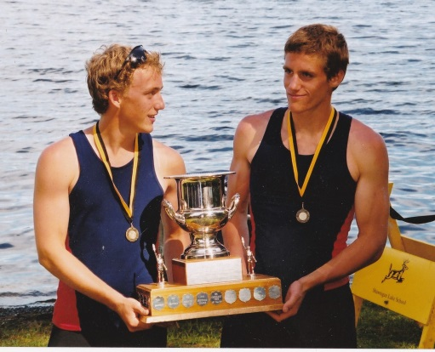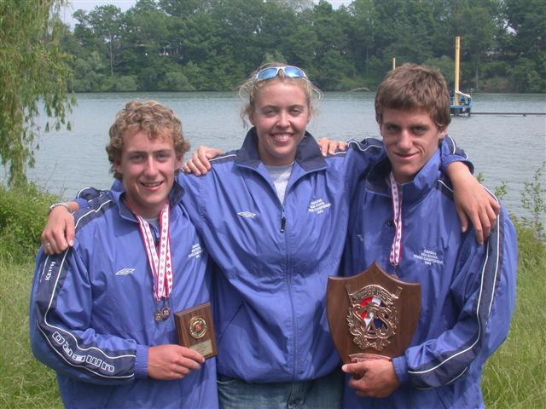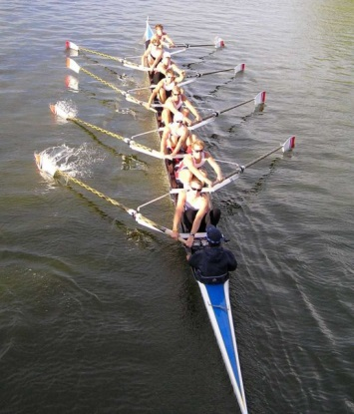
The 2005 Canada Games gold-medal men’s eight
Coach Sonja Leverkus stands between Keith and Danny
Keith and Danny after their win at the Shawnigan Lake regatta

