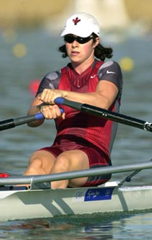
Kristen Wall
At Belmont, Kristen trained with school’s rowing program at Elk Lake under guidance of coaches Tom Hatcher, Scott Goodmanson, Silken Laumann and John Wallace. Kristen was already an accomplished rower by that time, and she competed for the VCRC club program.
After high school graduation, she was recruited to row at the University of Victoria, and was a member of the Uvic women’s eights squad that won the gold medal at the CURC championship in 1997. One year later, she captured the single skulls event in that same competition.
Kristen’s talents were recognized by the women’s national team coaches and she was selected to compete in a number of international events, including three world championship events. Her impressive resume also included a silver medal at the senior world championship in the women’s eights, and a 14th place finish in the single skulls at the 2000 Sydney Olympics.
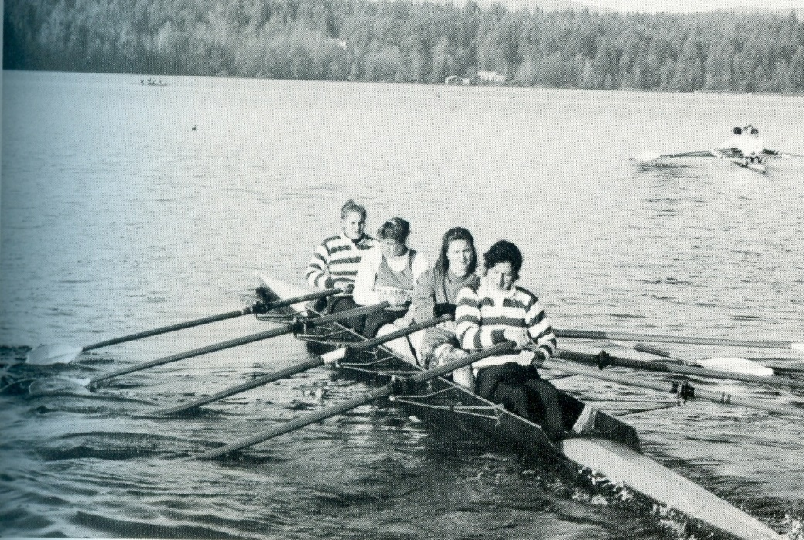
1992 Belmont yearbook photo of Belmont’s girls’ quad boat. Kristen is in the front, and her team-mates are Jennifer Brandel, Erin Miller, and Sheryl Malinowski.

