Manvir Sahota – 2005
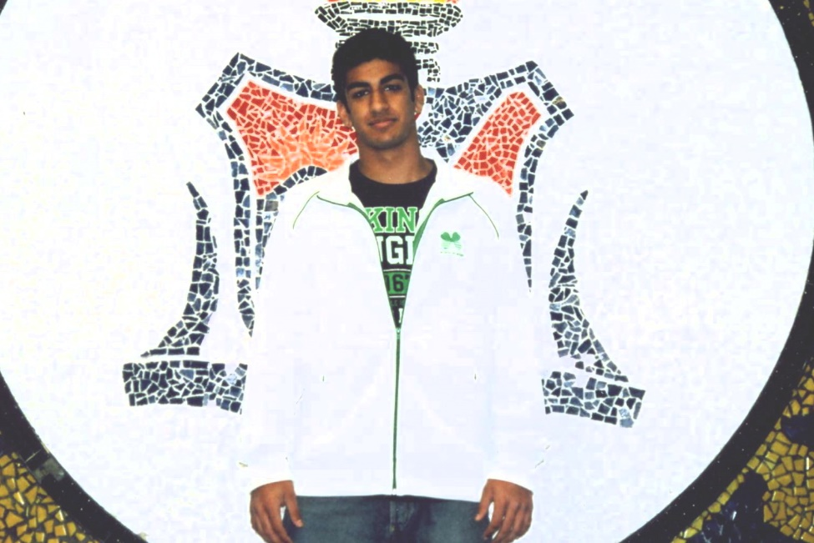

Manvir was a two time provincial wrestling champion in high school: the only Belmont wrestler ever to win the B.C. title! That same year, he won the silver medal at the Canadian National Juvenile Championship and accepted an offer to attend Simon Fraser University. He continued to excel at the collegiate level and won a bronze medal for SFU at the NCAA National championship in 2012 and earned NCWA All American honours.
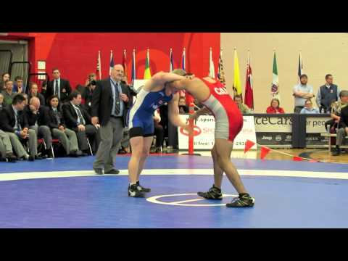
We do not have a current email address or phone number for Manvir. If anyone is able to pass on his contact information to the Belmont office, that would be much appreciated.

