Marilyn Kraeker
It requires a variety of personal attributes and technical expertise to become a successful head secretary of a large high school. Strong interpersonal skills, computer proficiency, the ability to multi-task, and tremendous organizational abilities are all important prerequisites. Marilyn Kraeker, Belmont’s secretary from 1994-2002, possessed all those qualities, which not only allowed her to perform her secretarial duties efficiently, but also helped her to become a valuable contributor to the school’s curling and golfing programs.
Curling has been a long-time passion for Marilyn and she is the person responsible for introducing the sport to Belmont in 1994. She organized a curling club, open to any interested students, regardless of whether or not they had prior experience and arranged inexpensive ice rental with the Juan de Fuca Rec Centre from 3:30-5:30 every Friday afternoon. Marilyn recalls there were usually about 25 students in the club and that everyone had a great time. Some of the more accomplished curlers competed in the high school league, and although Belmont teams didn’t necessarily achieve outstanding results, many of these athletes developed a life-long love of the game and continued to curl in adult leagues for many years after graduation. Marilyn says it always gave her great satisfaction to run into one of her former high school curlers who were still involved in the sport.
Besides her high school commitments, Marilyn was also heavily involved in the local and provincial curling scene, and in 1998 she embarked on the ambitious endeavor of bringing the provincial high school championship to Juan de Fuca. Belmont had never hosted a provincial championship in any sport and this was a massive undertaking, as $10,000 had to be raised in order to pay for ice rental, the banquet venue, food etc. Some of these costs would later be recouped, but the host school needed to take care of all the initial expenses up front. With her usual energy and determination, Marilyn managed to round up a large contingent of volunteers and convince local businesses to make donations. Alcan was the main tournament sponsor and supplied all the trophies for the event. As the host school, the Belmont team received an automatic berth into the competition. The tournament turned out to be a rousing success.
Curling wasn’t the only sport Marilyn influenced at Belmont; she also volunteered to take responsibility for the golf team in 1994. She didn’t have enough expertise in the sport to offer coaching in the technical aspects of the game, but that wasn’t a problem since the players all belonged to local clubs and received instruction there. Marilyn took care of all of the team’s organizational tasks and provided regular encouragement and moral support. In 1994, an enthusiastic young PE teacher and golfer, Ken Lowe, transferred to Belmont and was interested in coaching the golf team, so he and Marilyn agreed to work together. The two would form a successful partnership for the next four years that included a couple of trips to the provincials and one memorable BC championship. Some of the students nicknamed the coaching duo “Mom” and “Pop.”
Fund-raising was an important component of any high school team’s ability to participate in out-of-town tournaments, and Marilyn recalls one memorable activity to raise money to attend the BC Championships in Kamloops in 1999. The municipality of Colwood had recently cleared an area for construction and offered to donate the fallen trees if the Belmont golfers would find a place to store them. Former Belmont athlete John Bodman, whose son Brian played on the1998-98 team, volunteered his property as a storage facility, so the trees were duly deposited. Meanwhile, Marilyn had gone into her organizing mode and presold many orders for cords of firewood at $70 per cord. She John rounded up all the boys and they spent the entire weekend chopping and delivering wood. It turned out to be a much more complex and physically demanding task than originally anticipated, as these were large trees that had to be completely stripped, cut into large rounds, and finally split into more manageable pieces. However, it was worth it as the venture turned out to be very profitable and helped pay for transportation and hotel costs for the Kamloops trip.
The culminating moment of Marilyn’s high school golf association occurred in May, 2002 when the Belmont team captured the BC Championship held in Victoria at Cordova Bay Golf Course. This was extra special for Marilyn as she had retired at the end of first semester that year and thought she was ineligible to maintain her association with the team. She recalls that one of the grade 12 golfers phoned her to ask her a question about practice times, and when she told him she wouldn’t be able to be involved anymore, he replied, “But you have to come back because we’re going to win the banner for you.” The boys apparently received confirmation from the school district authorities that she was able to rejoin Ken Lowe and the rest of the team and the team made good on its promise by bringing home the banner that now hangs in the Spotswood Gym.
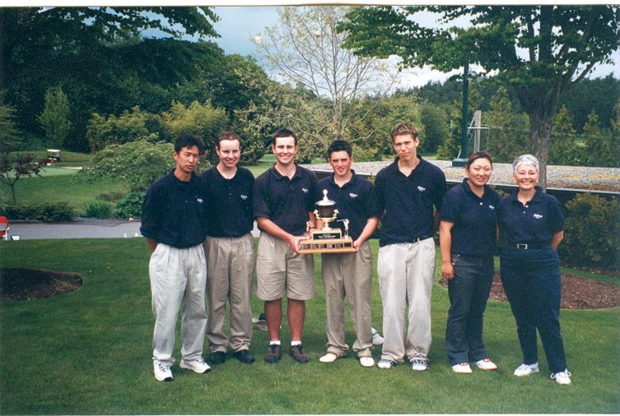
Marilyn is standing on the far left along with the members of the 2002 BC Championship golf team.
Although Marilyn is no longer involved with high school sport, she has remained heavily involved the curling community at the administrative level. She was instrumental in bringing the Canadian Junior Curling Championship to Victoria in 2002, and has been a director of both the Men’s World Championship bonspiel and the Scotties national ladies’ championship. She’s not ready to slow down yet and has aspirations to bring future high profile events to Victoria. Although her various projects can be very time-consuming, Marilyn still makes sure to schedule regular curling and golf games into her weekly routine.
Belmont was very fortunate to have someone with Marilyn’s passion and organizational abilities so involved with the curling and golf teams, and we thank her for her many contributions to the school’s athletic program.

