Mark Nelson: 1999-2001
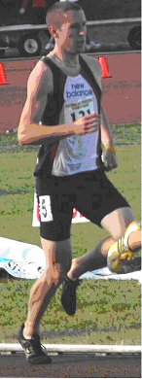
Mark is a multi-sport athlete who participated in track and field, cross country and soccer at Belmont, and also competed for the Juan de Fuca Soccer Association and the Victoria Track and Field club in the community. Running became his main focus by high school, and he developed into one of the top middle distance runners in the province. His grade 12 season, Mark won the 800 meter event at the Vancouver Island Track and Field Championships with a time of 2:00.28. Two weeks later in Vancouver, he raced to a third place finish at the provincial championship meet. The B.C.’s were held the same weekend as Belmont’s graduation ceremony at Uvic, so Mark had to board a float plane right after his event and hurry back to Victoria. He arrived just in time to cross the stage and receive his diploma!

Mark has many positive memories of his involvement with Belmont athletics, and recalls that he particularly enjoyed running the 4 x 400 meter relay with Dave Seager, Mike Seager, and James Berry. The four grade 12 boys captured the gold medals at the Island Championship and followed that up with a top five result at provincials.

After high school graduation, running became Mark’s main focus for the next five years and he competed at the collegiate level for the Pacific Institute of Sports Excellence. Mark has two highlights from his post-secondary time that he will always remember. One was pacing Nick Willis (a future Olympic Silver medallist) in the Men's 800m at the Victoria International Track Classic and helping him attain his Olympic qualifying standard. The second was running the Gore-Tex Trans-Rockies Run with his wife and winning 5 of the 6 stages of the grueling 6 day, 200km stage race in Colorado.
Athletics have created career opportunities for Mark and allowed him to meet a number of great people, including Rob Reid of Frontrunners Footwear. He worked for Frontrunners during his time training post high school and ultimately purchased a franchise of Frontrunners in 2005 which he owned until he sold it in 2012. He believes that the skills he learned through sport and through Frontrunners led him to create RaceOnline Registrations (www.raceonline.ca) in 2008, which has now grown into one of Canada's largest online registration providers for sporting events.

Mark credits a number of people who helped him achieve his athletic success. His parents were great at getting himself and his siblings into sports without any pressure, an attitude he believes all parents should adopt. His club coach Arthur Taylor was one of the most influential and respected people in his life. Marks explains Arthur instilled hard work, modesty, and honesty into all of his athletes and helped shaped me into the person I am now.”

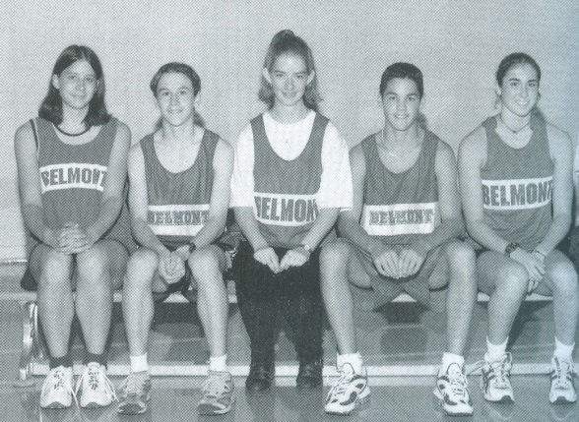
Although an Achilles tendon injury has restricted Mark’s ability to run consistently the past several years, he still managed to complete his first marathon in 2012 and hopes to run personal bests in half-marathons and marathons in the next few years. He has also taken up mountain bike and cyclocross racing and is thoroughly enjoying the experience of taking up a new sport.
