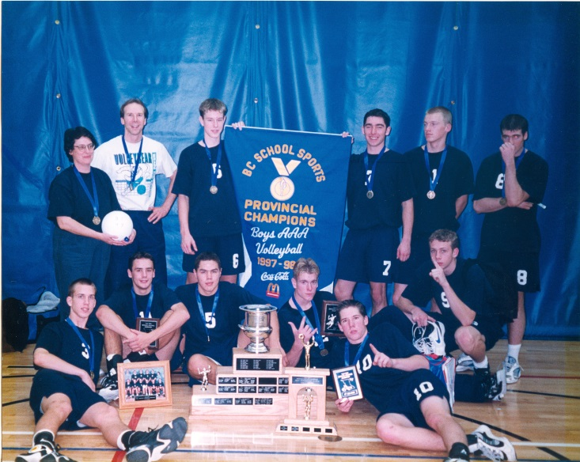
Mike Strandlund: 1994-1997
As a junior, while attending Spencer (then a junior high) Mike was a key member of the Boys Volleyball Team that won the “triple crown” – Cities, Islands, and B.C. Championships in 1996. That same year Mike played club volleyball with the Victoria Fever, which won the U-16 Boys National Championship. At Belmont, as a Grade 11, Mike was a first team all-star several times, including the 1997 AAA Provincial Championships in Kelowna, where Belmont would win its first ever B.C. Championship banner. The following year Mike was a big reason why the team was able to make it back to B.C.’s, winning first team all-star at the Islands (Belmont finished 2nd) and a second team all-star at the 1998 B.C.’s (Belmont finished 5th).
After high school graduation, Mike would go on to the junior provincial team in 1999, where he competed in the Junior Olympics in New Orleans with Team BC. Mike Toakley, who coached Mike at both Belmont and Spencer, described Strandlund as an “all-round player, with amazing hand-eye coordination. He was not the biggest player, but he hit and served hard and was a serve receive machine.”
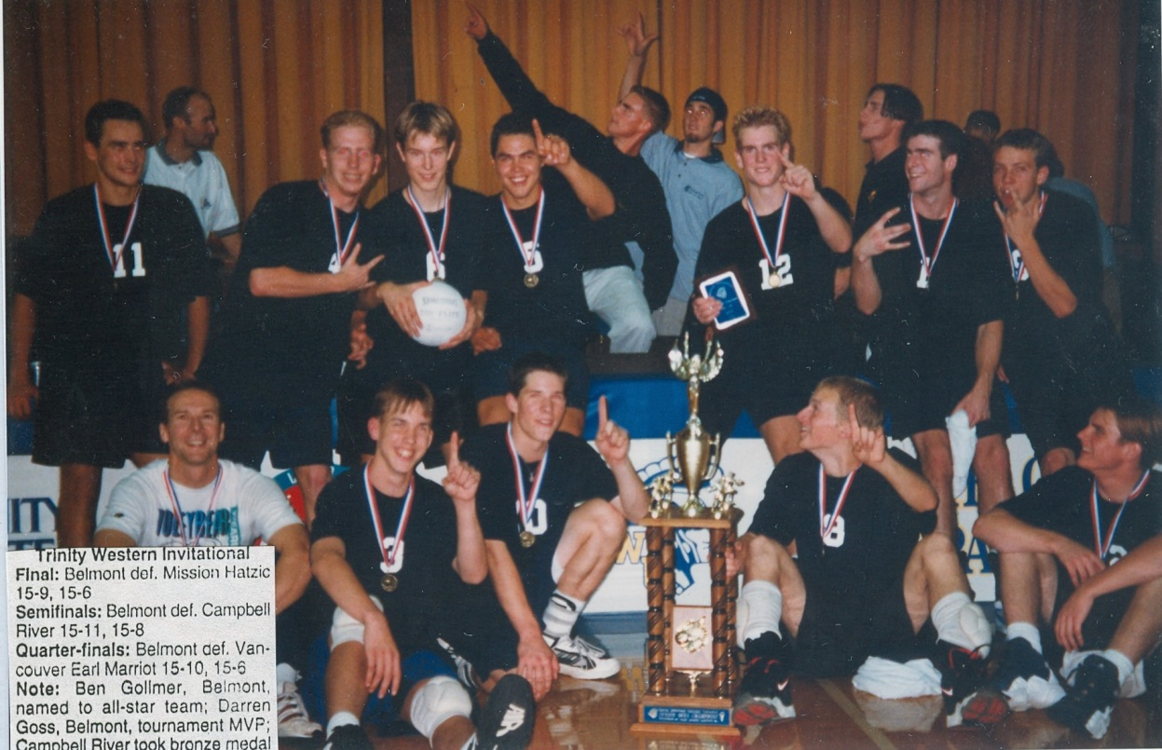
Mike (#10) is sitting on the floor 3rd from the left in this photo and lying down on the far right in the top photo

