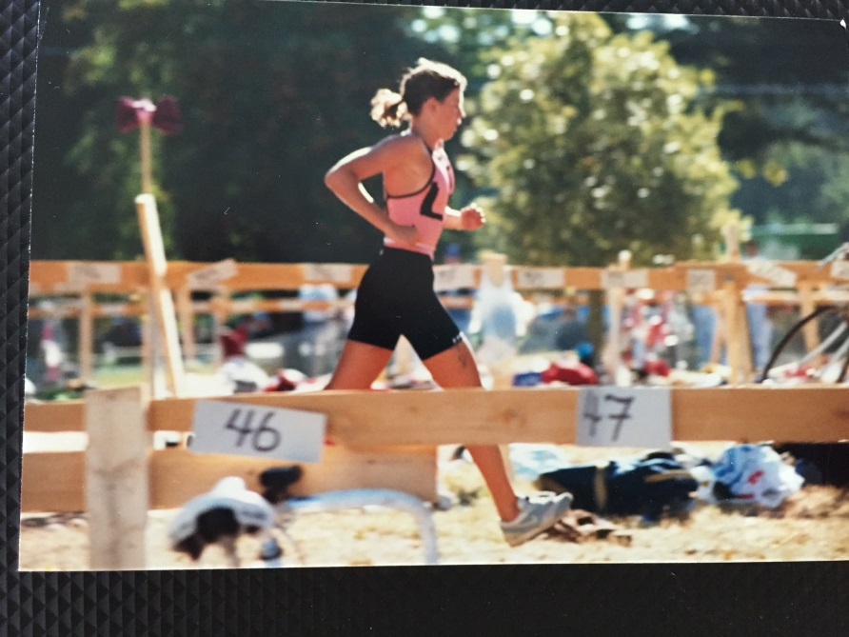
Patti Armstrong Schmidt 1984
Patti, co-winner of Belmont’s top senior athlete award in 1984, was a well-rounded athlete who excelled at swimming, cross country and track and field during her high school years. She began competitive swimming with the Spartan Swim Club in Chilliwack, BC at the age of 12 years old. Once she started Belmont she was recruited for the cross country team and loved to compete in the running races.
In Patti’s grade 12 year, she led the girls’ cross country team to a silver medal performance at the provincial championship in 1983-84, winning an individual gold medal at the City Cross Country championship and a 2nd place result at Islands. Patti found her city title to be especially rewarding as her younger sister Elizabeth won gold in her age group at the same meet. She says one or her best high school memories was the trip to the Interior for the BC’s that year with their coach Mr. Horton, as it was a close-knit group and had a great time together.
Not only was Patti one of the top high school runners in the province, she was also a nationally ranked swimmer, and earned medals at the Island and BC championship meets in grade 10, 11 and 12. She competed in the 1984 Olympic Trials in Toronto her senior year and finished 12th in the country in the 200m backstroke event. She recalls having to study throughout the competition and writing one of her provincial final exams at a local Toronto high school.
After high school graduation, Patti attended Uvic on a swimming scholarship and won a bronze medal at the CIS nationals in her rookie year. She also won a number of relay medals during her collegiate career. Following her swimming career she began the sport of Triathlon and competed at the highest level, eventually meeting her husband in the sport. After graduation from university she began my professional career at the University of Victoria and over time became the Coordinator of Athletics for the Vikes Athletic program.Along the way, she and her husband had three children, all of whom are very athletic and compete and or competed at the National and International level in swimming.
Patti credits a number of people for contributing to athletic success. Her swim coach Jock Noble of the COHO Swim Club “was a very positive, caring and kind coach who guided me through some difficult times. As well, my parents were VERY supportive of my athletics and were always available to drive me to the early am workouts and volunteer long hours at the many swim meets I attended.”
Her advice to current Belmont athletes is to “Study hard, train hard and never stop believing in yourself. Learn the skills of time-management and organization. Always have a goal! Have fun!”

