Randy Smith: 1941-2001

Randy Smith was a prominent Belmont coach from the mid 1960s to the late 1980s, and guided a number of teams to top ten finishes in the province. He was a gifted athlete himself who excelled in swimming volleyball and tennis. Randy was the athletic director on UVic’s student council for several years, a certified lifeguard, and the Pacific Northwest Tennis Champion in the early 1960’s. He spent many summers teaching tennis to Victoria’s teens in the city parks.

Randy started his teaching career at Belmont in 1965 and made an immediate impact on the school’s athletic program. He coached swimming, volleyball, tennis, cross country and soccer and was a teacher-sponsor for the strong intramural program that existed at that time. Along with fellow coaches Ernie Teagle and Stan Powell, Randy donated most of his lunch and after- school hours to coach teams or to play informal (but highly competitive) floor hockey matches with groups of boys in the gym.

Belmont’s swimming program progressed quickly from its inception as a recreational club; to one of the top programs in the province. Randy and Stan Powell were the teachers most responsible for this achievement. The team began practicing at Victoria’s Crystal Pool, moved to Royal Roads University, and later trained at the Juan de Fuca’s Centennial Pool when it opened in 1967. A demanding coach who pushed the athletes to work hard, Randy and assistant coach Sylvia Dockerill (a Canadian national team swimmer) were playfully described in the 1976 yearbook swim team write-up as the “miserable duo” who subjected the students to tough workouts. Nonetheless, swimmer Linda Crabb captured the gratitude of the athletes towards their coach: “We would like to convey our deep appreciation to Mr. Smith, our persistent “commander in chief” who compelled us to excel to points beyond our capacity – on to success and victory,”
Randy is kneeling on the far left with the 1975-76 swim team that finished third in the province, the school’s best ever finish in swimming

Boys’ volleyball was another sport that Randy helped elevate to serious championship contenders. In 1969-70, he helped mould a group of inexperienced players into Lower Island champions, the first time any Belmont volleyball team had accomplished that feat. The boys went on to finish 2nd at the Island Championship, another ‘best-ever’ Belmont result.
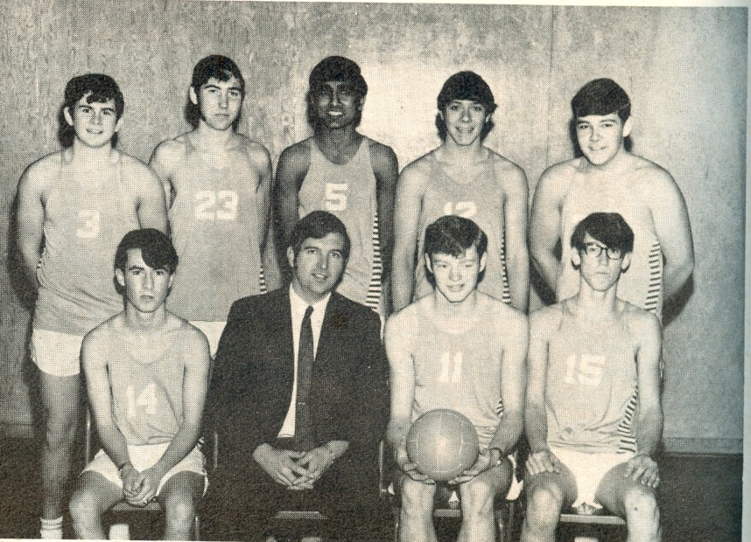
Randy with the 1969 “Rinky Dink” boys’ volleyball that won Belmont’s first Lower Island title

Despite the impressive results, Randy’s legacy to Belmont’s athletic program cannot be measured in terms of wins or championships. He had a gift of being able to connect with young people. In his role as a coach and as a school counsellor Randy offered support, guidance and life lessons to many students.

