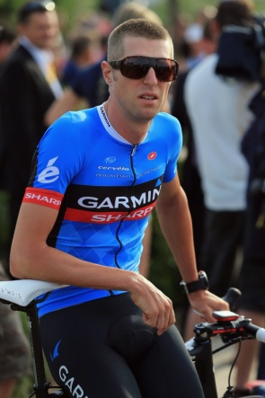
Ryder Hesjedal – 1996-1998
As a youngster, Ryder was a multi-sport athlete who participated in basketball and baseball as well as mountain biking. By the time he was a student at Spencer, he was already starting to make a name for himself as one of the top young mountain bikers in town. In his teenage years, Ryder decided to focus solely on cycling and steadily rose up the provincial and national ranks.
By the time he graduated from Belmont, Ryder had become a legitimate national contender, and in 2003 won a silver medal at the World Championship. He was one of the gold medal favorites at the 2004 Olympics in Athens, Greece, but his dreams of a top podium finish were shattered by a punctured tire that forced him to drop out of the race. Ryder’s Olympic experiences were not over though, as he competed in the road races in the 2008 Games in Beijing and again in 2012 in London, England.
Ryder switched from mountain biking to road racing, and soon achieved outstanding success. Known for his cardiovascular stamina and tough mental approach, he particularly excelled at the grueling mountain climbs, that took such a physical toll and tested the rider’s inner fortitude. This served him well in high profile events such as the Tour de France, that included long, steep mountainous sections. In 2008, Ryder’s consistency and longevity were recognized when he was named Canadian Cyclist of the Decade. In 2012, Ryder captivated the country as he placed first in the prestigious 21 stage Gira d’Italia: becoming the first Canadian ever to win a European Grand Tour cycling event! This impressive victory was instrumental in him being selected as Canada’s Top Athlete of the Year and seeing his name engraved on the Lionel Conacher trophy.
When asked about his Belmont memories in an April, 2015 email interview by Goldstream Gazette reporter Arnold Lim, Ryder responded, “For me, Grade 11 and 12 were exciting years, and it was there that I set out on my way to being a professional cyclist.” He added some thoughts about the move to the new Belmont building. “I hope the new school is even more inspiring for all the students and the teachers. It’s sad to see a place go that has great memories, but it’s about building for the future and always moving forward, so I’m excited to see the new Belmont in action.”
As a perennial national champion, Gira d’Italia winner, three time Olympian, and international riding celebrity, Ryder will undoubtedly continue to be an inspiration for future Belmont athletes.
