Sara Herbert

Sara was active in a number of sports at Wishart Elementary School, including cross country, track and field and basketball. She was part of a powerhouse girls’ basketball team that also included Belmont Sports History student researchers Lindsay Hargreaves and Claire Joyce. The squad went undefeated in both their grade 5 and 6 seasons.

At Dunsmuir Middle School, Sara continued to be one of the strongest athletes and focused on volleyball and basketball as her two main sports. In grade 7, she joined the Westshore Warriors community basketball team that did very well in the Victoria City Night League. She also became heavily involved in the school’s music program, both in the band and choir.

Sara continued to balance fine arts and athletic pursuits when she moved up to Belmont. In order to be able to attend both basketball and musical theatre practice schedules Sara moved up to the senior girls’ basketball team in grade 10 and continued to be one of the stronger post players in grade 11. Unfortunately a serious injury ended her grade 11 season early and she decided not to play her grade 12 year.

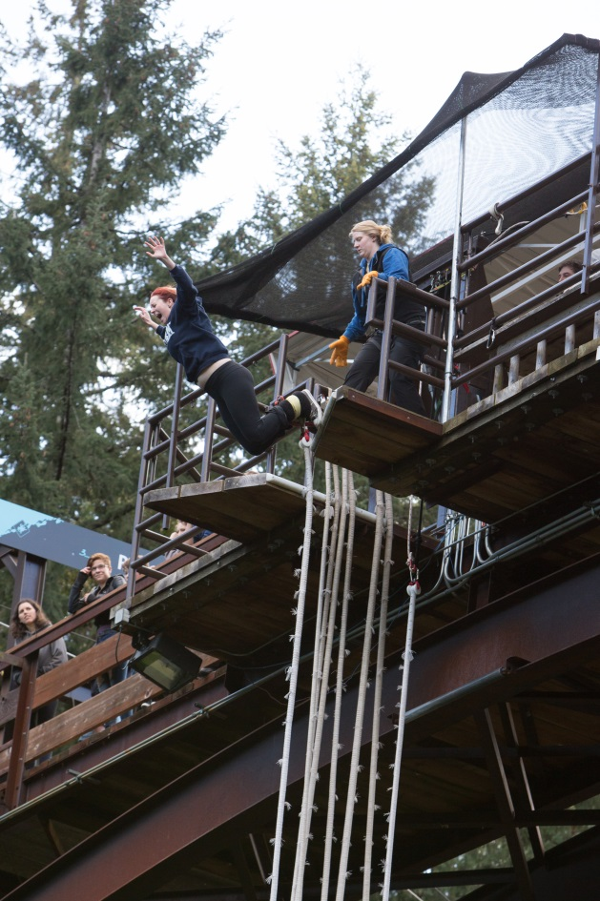
When asked about her experience with the sports history project, Sara replied that she’s really enjoyed learning about the former Belmont athletes. She loves history and has found it very interesting to research the grads and to discover how many of them continued playing sports throughout their adult lives.

Sara leaping off the platform for a bungee jump to celebrate her 18th birthday

