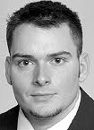
Scott Kral: 1993-1996

Scott, nicknamed “The Grinder,” attended Belmont from 1993-1996. An all-round athlete, he played basketball, soccer, volleyball, track and golf at school. He first started playing sports in elementary school in about grade five, and took up golfing at the age of twelve. He played at the Olympic View course, which was convenient because he lived just up the street and rode his bike there. Scott said he “basically lived at the golf course in the summers.”
Scott’s believes his top sporting achievement at Belmont was finishing second two years in a row at the BC High school championships in the individual component of the tournament. His best high school sporting memory at Belmont was driving to Castlegar to the BC championships in 1996. “Great trip, it was so fun. Team finished 2nd, I finished 2nd for individuals.” He captured the BC Junior Championship two years in a row, winning by an amazing ten shots the second time. His impressive junior record led to him receiving a full golf scholarship at the University of Washington. He spent four years there and graduated with a BA in Sociology.
After earning his university degree, he turned professional and played for three seasons on the Canadian Tour, golfing for a living. He credits much of his success to his coach Earl Davies, direction of instruction at Olympic View Golf Course. “I wouldn't have achieved anything if it wasn't for my friend and golf coach growing up. He saw me hitting balls on the driving range one day and gave me some pointers and told me that he would coach me. From that day on he taught me everything about golf, and never once charged me a penny. Wonderful man with a huge heart and an incredible love for golf.”
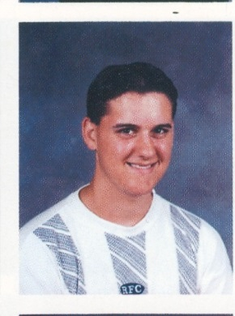
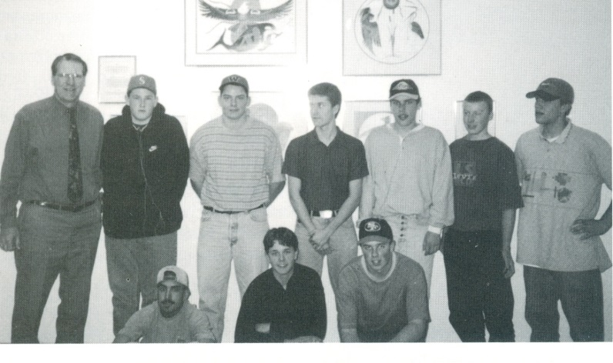
Scott’s advice for today’s student athletes would be” to not get caught up in the awe of others and stick to your own game. Be confident and never stop practicing. The harder you work the luckier you seem to get. Not a coincidence. “
Scott with his 1995-96 Belmont golf team-mates. Scott is standing in the back row 3rd from the back. The team was coached by Tom Hatcher that year.

