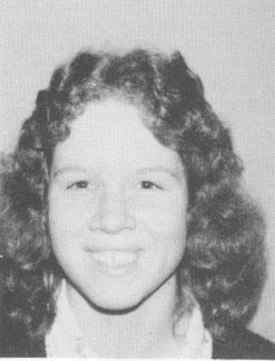
Sheila Chalmers 1976
Sheila Chalmers, Belmont’s top female athlete of 1976, was a talented natural athlete who excelled at basketball. She was a first team Vancouver Island All Star and led the 1974-75 Tomahawks senior girls’ basketball team to their first ever berth in the provincial championship tournament. Her coaches remember her as an intense competitor who inspired her team-mates with her hard work and fiery personality.
We do not have contact information for Sheila. If anyone is able to forward her phone number or email address, that would be much appreciated.

