The 1950’s: History of Belmont Athletics
1949-50 marked the first graduating class of the new Langford high school, and 16 students walked across the stage to receive their diplomas. In three short years, these young men and women had helped Belmont establish the foundation for a strong sporting tradition, and throughout the first half of the 1950’s, Belmont’s athletic programs continued to mature. Volleyball and basketball were added to the sports curriculum, although the absence of a proper gym still presented a major obstacle and the teams had to practice outdoors on the asphalt surface.
In 1953-54, the PTA and School Board combined forces to form a new grounds committee to finally complete the Belmont field. Yearbook writers Muriel Pollack and Robin Price describe the procedure.
“So far, the work accomplished by the school board has been levelling the ground and applying topsoil. The PTA supplied the lime which was put on the soil last fall. Several work parties were formed to remove rocks. The successful laborers were rewarded with refreshments supplied by the school board. The girls were present to boost the morale of the stronger sex.
The field is approximately one acre in size. It will be used as a grass pitch for soccer and softball games. The lower end will be the starting point for a cinder track.” (Pollack and Price 1954)
Despite the celebratory report about the new field, the troublesome issue of rocks would remain into the early 1960’s, as several grads from that era commented upon the uneven playing surface and recalled rock-gathering as the standard detention punishment. Carol (Booth) Varcoe, a grad of 1963 wondered what happened to all the rocks, an interesting question considering the volume that must have been collected over a 15 year period.
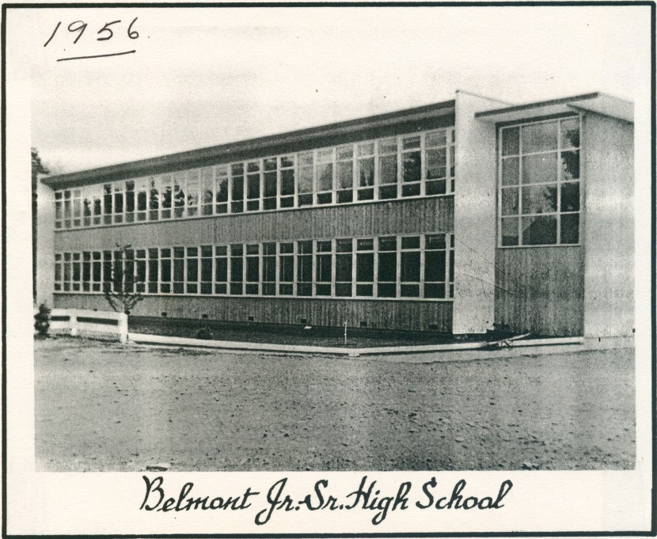
1954-55 was an exciting time as construction was completed on a permanent new Belmont building at a total cost of $177,000. A highlight was the 7000 square foot gymnasium (the current Spotswood or South gym). A formal opening ceremony occurred January, 23, 1955 when the minister of education, the Honorable R.G. Willison, presented the key to the school to Belmont principal Archie Stephenson and student council president Bernard Wachter. The new facility wasn’t large enough to accommodate all the students, so the grade 11 and 12 academic courses were scheduled in the brand new classrooms, while the younger grades and some of the vocational programs remained in the army huts.
The opening of the new gym led to significant expansion of the school’s athletic programs. Basketball, badminton and indoor track meets were added to the house competitions, and a fifth “E” House was created to accommodate the growing number of students. The basketball and volleyball teams were now able to conduct full practices on site and to host home games.
The following year the Sports Council decided to replace the original alphabet house team designations with more descriptive names, and the Council selected local First Nations groups. The sports section of the 1956-57 yearbook outlines the transformation.
“After many brutal threats and some coaxing, we have finally established our tribal names. It is now clear to all that to use the old house names is equivalent to cursing under the breath in Math Class. At first, the names proved to be tongue twisters, but by this time, every Belmont student knows how to pronounce Kwakuitls, Tsimishians, Toquots, and Salish. For convenience sake, the latter two have been shortened to “Kwaks” and “Simshies.”
Along with the new names, each house was also designated an animal emblem or crest: the Raven, the Bear, the Killer Whale, or the Beaver. The original drawings were outlined in the 1956 “Kee-Yu” school annual.
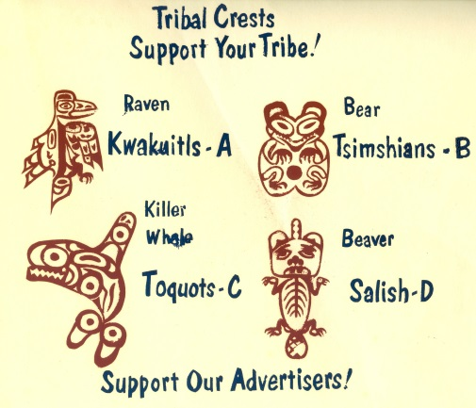
The aboriginal theme continued with the creation of a “Tribal Track Meet” each spring and the christening of the senior boys’ basketball team as the Braves. The senior girls were known as the Bravettes (later to be changed to the Tomahawks when coach Bill Spotswood took over the team), the junior boys were the Huskies and the junior girls were the Belles. In those early years, Belmont didn’t have an official mascot or school sports team name, and each sport had their own names, which, except for basketball, tended to vary from year to year. For example, the 1959-60 boys’ soccer team was called the Butchers, and the later 1969 boys’ volleyball team had the curious title of the Rinkydinks. Selection of aboriginal names for the houses and basketball teams was a reflection of the times and certainly was not intended to be offensive in any way, but over forty years later, students from Paul Waterlander’s First Nations 12 class would challenge the school to adopt racially neutral names for the basketball Braves and their female “Tomahawks” counterpart, which led to the adoption of the current Bulldog mascot.
1957-58 was Belmont’s most successful athletic year in the school’s short history, as the track and field team captured the Lower Island championship, edging out second place Salt Spring by a score of 88-87. The Langford athletes were led by Don Robson, who recorded first place finishes in the senior boys’ long jump and the hop, step and jump and Cecilia Hall, who won the junior girls’ high jump and the hop, step and jump. Other event winners included Cliff Kilduff in the 880, B. Carlow in the high jump, Brian Calloway in the 440, and Geoff Hett in the one mile race. The Braves basketball team recorded their best ever result with a 3rd place finish in the Lower Island Championship tournament and a 6th place finish at the Vancouver Island tourney where captain John Batchellor was named a second team all star. This year also marked the emergence of Belmont’s first cheerleading squad: Angela Gurr, Sandy Wiart, Sandy Atchison and Carole Wachter remained together for two years and offered their enthusiastic support at every basketball game. On the downside, for the first time the senior boys failed to field a soccer team which provoked a stern reprimand in the 1958 yearbook sports section: “This is shocking, as every other year Belmont has had very successful teams. Let’s pull up our pants, fellows, and do better next year.”
Several members of the Belmont graduating class of 1958-59 took the initiative to create a year-end award system. Gary Tindall headed the “Awards Committee of the Supervisory Council” that also included Geoff Hett, Cliff Baird, Sheila Edwards and Donna Cameron. Recognition was given for academics, clubs, and sports, and the winners were selected by the students rather than teachers. According to the yearbook summary, senior athletic award recipients appear to be Bill Spotswood (basketball), Geoff Hett (basketball, softball and cross country), Carol Newcomb (basketball and softball), Peter Parker (swimming), Cliff Kilduff and Rod Kilduff (senior boys’ interhouse) , and P. Turner, Sharon Reece (senior girls’ interhouse). The committee clearly had high standards and reserved the right to withhold a particular award, as evidenced by the following yearbook comment: “No award was made for Senior Best Effort this year. Although many individuals contributed much to Interhouse activities, the lack of genuine support from most seniors was the determining factor."
The late 1950’s welcomed the arrival of Mr. Stan Powell to Belmont, who became an influential teacher and coach. Mr. Powell was an avid swimmer and he organized the school’s first swimming team in 1958-59. The group practiced every Thursday afternoon at the old Crystal Pool on Douglas Street, located across the street from the current Convention Centre. The team entered the City high school meet, and although the team struggled in their first competitive season, they later developed into serious contenders. Besides his swimming duties, Mr. Powell also took over the senior girls’ basketball team and tried to organize a rural school league for Belmont, Milne’s Landing, Mt. Newton, Royal Oak and North Saanich.
In the 12 years from 1947-1959, Belmont School had evolved from a one room annex at Albert Head, to a collection of assembled army huts, to a modern high school. The athletic program had made similar dramatic changes, as Belmont athletes had progressed from the days when softball, track and field, and boys’ soccer were the only teams and Milne’s Landing the only opponent, to a school that offered multiple sports and competed in organized Lower Island leagues and competitions. Many talented athletes, along with a number of dedicated volunteer coaches, had laid the foundation for a strong and lasting athletic program.
Compiled by Cindy Cullen -2015

Bibliography
"500 Attend Belmont Reunion ." 30 1970, January.
Jacobson, Gaye. "Valedictory, 1950." Pioneer Edition Belmont Annual, 1950.
Josephson, Bonnie. "History of Belmont High School." Written Summary for SD 62, Victoria, n.d.
Kerley, Don. "Letter to the Editor." Goldstream Gazette, August 25, 2009.
Le Quesne, Allen, interview by Cindy Cullen. Recollections of Belmont School in the early 1950's (July 22, 2014).
Mansfield, Earl. A Brief History of Belmont Senior Secondary School. Victoria: Belmont School, 1994.
Maughan, K.E. "History of Belmont." Blue and White Belmont Yearbook (Belmont School), 1951.
—. "History of Belmont." Pioneer Edition, 1950.
"New Belmont High Off to Busy Start." 1954.
"New Principals Named for District Schools." 1966.
Pollack, Muriel, and Robin Price. "PTA Sponsors a New Field in Conjunction with the School Board." In 1953-54 Yearbook. Belmont Secondary School, 1954.
"Resolution." Town council resolution, Victoria, 1947.
Robertson, Alan, interview by Cindy Cullen. Recollections of Belmont Athletics in the Early 1050's (July 24, 2014).
Smith, Shirley, interview by Cindy Cullen. Recollections of Belmont Athletics in the Early 1950's (August 5th, 2014).
Times. "Milne's Landing Wins Inter-High Sports Day at Belmont School." Victoria Daily Times, June 4, 1949.
Varcoe, Carol (Booth / Spotswood), interview by Cindy Cullen. Belmont memories (August 19, 2014).
Yearbook staff 1950, Bill Parker editor. Pioneer Edition. Victoria, 1950.
Yearbook staff 1951, Bill Parker editor. Blue and White 1950-51, 1951.
Yearbook staff 1952, Sinclair Ash editor. Blue and White 1951-52, 1952.
Yearbook staff 1953, Holly Francis editor. Blue and White 1952-53, 1953.
Yearbook staff 1954, Marjorie Creasser editor. Kennyai Yuens 1953-54, 1954.
Yearbook staff 1955, Sheilla Arden editor. Keenya Yuens. Victoria, 1955.
Yearbook staff 1957, Donna Spears editor-in-chief. Kee-Yu. Victoria, 1957.
Yearbook staff 1958, Bunnie Jacobson editor. Kee-Yu. Victoria, 1958.
Yearbook staff 1959, Sharon Raynor editor. Kee-Yuu. Victoria, 1959.

