Belmont Sports History from the 1970’s
The 1950’s and 60’s laid the foundation for Belmont’s athletic programs and established the Langford school as a legitimate contender in a number of sports, paving the way for the school’s teams and athletes to reach new levels of success in the 1970’s. This was a decade in which Belmont teams regularly medalled at Island championship tournaments and advanced to provincial championship tournaments. Some grads from this era went on to play at the university level, and a couple even made Canada’s national teams.
Several highly influential coaches appeared on the scene: Muzz Bryant arrived as a practicum student in 1972 and would continue to coach for the next 37 years, mainly with boys’ basketball and soccer. Bill Spotswood moved over from Elizabeth Fisher in to take assume control of the senior boys’ basketball team and would later switch his focus to girls’ basketball and field hockey. Tom Holmes, Patti O’Neill and Val Baker all coached their first Belmont teams in the mid 1970’s, and although the trio would leave for Dunsmuir in the 1980’s, all would return to the high school to complete their teaching and coaching careers. Marta Vaesen was a noted volleyball and field hockey coach who led the 1973-74 senior girls’ volleyball team to their first Lower Island title and a trip to the BC championship tournament: the first girls’ team from Belmont to ever accomplish that feat. Pam Henson, a UVic Vikettes basketball grad and member of a Senior A women’s national championship team, joined the Belmont staff in 1973 and quickly left her mark on the athletic program. Within two years, Pam had guided the senior girls’ basketball teams to their first-ever berth in the provincial high school championship tournaments, and she also helped coach volleyball, field hockey and track & field. Prominent coaches from the 1960’s, Randy Smith, Stan Powell, and Ernie Teagle all continued to volunteer their services on behalf of Belmont student-athletes.
By the early 1970’s, Elizabeth Fisher Junior High School had become a noteworthy athletic school, with several teams making their mark in city and Island competitions. The Glen Lake PE runs, had helped to produce some strong distance runners, and cross country coaches Mr. Coupland and Mr. Jackson offered tough training sessions for interested athletes. All that training paid off in 191-72, as 30 junior runners, nicknamed “Big Black and Gold Machine,” dominated in local races, winning the interschool league title, the 21 mile Beacon Hill relay and the Thetis Lake relays. To cap off their highly successful season, the team brought home the school’s first Vancouver Island title, with the midget and junior boys placing first, the junior girls second and the midget girls third. Top individual performers were Gail Edgington, Betty Bultena, Dan Clements and Gordie Evans.
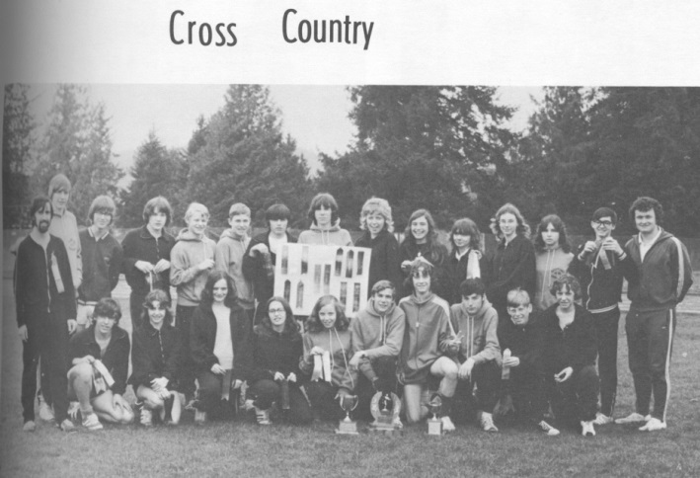
The victorious Elizabeth Fisher cross country team display their ribbons and trophies.
1973 was another triumphant year for Elizabeth Fisher sports teams. Bill Spotswood’s junior boys’s basketball squad rolled to a record of 43 wins and only 4 losses. The Sun Devils won the Victoria and District Bantam championship and later thrilled the hometown supporters by winning the Vancouver Island junior championship that was held in Belmont’s gym. The boys advanced to the BC bantam tournament in Vancouver and placed second in the province, with Rick Reece and Ted Cuckovich being selected as first team all stars. A few months later, the Elizabeth Fisher track and field team placed first in the inter-district competition, bringing yet another title back to the school.
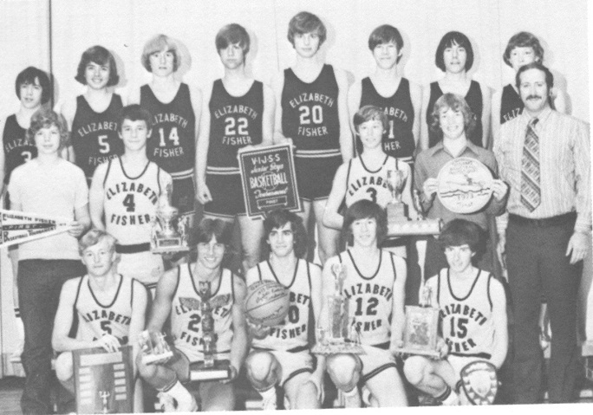
The Sun Devils basketball team pose with coach Bill Spotswood after their 2nd place finish in the provincial championship tournament.
Belmont underwent a significant transformation in 1973-74 when the high school amalgamated with its junior feeder school, Elizabeth Fisher. Rumors of a possible union had been circulating for a couple of years which created feelings of angst and trepidation. Many people in the community questioned the wisdom of creating a single school with a population of 1600 students. Elizabeth Fisher principal John Holt described the 1972-73 school term as the “Year of Uncertainty” in his Driftwood message. The 1973-74 yearbook “Dedication” page categorized the joining as “an event that generated a lot of controversy and criticism.” After acknowledging the initial reservations, the writer congratulated the staff and students for their efforts in trying to make the year a success, and offered these encouraging words: “Belmont-Fisher, pat yourself on the back. You’ve been two schools, now you’re one great school. Be proud of your name and the people from Belmont-Fisher.”
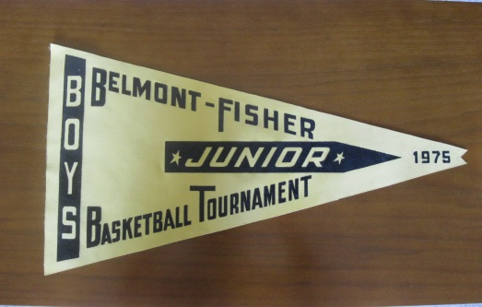
The pennant shows the new Belmont-Fisher name that was used for two years only.
It was not only the students who came together to form a single unit; the Elizabeth Fisher and Belmont buildings were physically joined to create one large building and the school was renamed Belmont-Fisher. The office, mall area, cafeteria, and library were all part of the new construction that filled the former space between the two neighboring buildings. The junior and senior sports teams were re-structured into one cohesive program under the leadership of a single athletic director. The old Elizabeth Fisher gym was now called the North Gym and the original Belmont gym became known as the South Gym. The school only kept the hyphenated name for two years before the “abandonment of the rather clumsy name Belmont-Fisher” in 1975-76. (Holt 1976).
Although the uncertainty surrounding the pending move may have caused some anxiety, the athletic program didn’t miss a beat, as many of Belmont’s senior sports teams recorded best-ever finishes. The Braves’ basketball team reached new heights in the early 1970’s, led by future UVic Vikings star Lee Edmondson, sharp-shooting Jim Kupiak, and hard-working John Hunter. In 1970-71, the boys captured Belmont’s first ever league title, placed second at the Islands and became the first Belmont team to advance to the provincial tournament. One year later, they topped these results by taking home the Island title and finishing 3rd at provincials under the guidance of coach Wally Russell, in his last year with at Belmont before leaving to become principal of Mt. View High School.
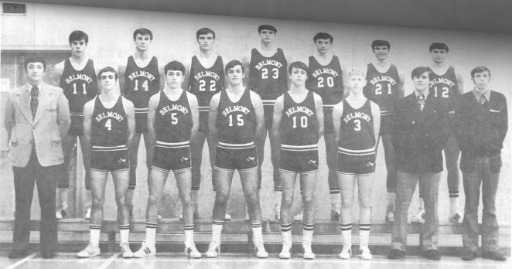
1971-72 Belmont Braves basketball team. Lee Edmondson is #23 in the back row.
Lee Edmondson captures the “coming of age” feeling that surrounded the school in the early 1970’s, as he recalls his first league game for the basketball Braves during his freshman season:
“Belmont was thought of as the backwaters of everything in those days and no one even considered Belmont Basketball as anything other than another easy win. We had been at a pre-season tournament the week before in Courtney I think and played Reynolds Sr Secondary in the final (they were the pre-season favourite to win the Victoria League and we surprised everyone (not the least of all ourselves) and won the tournament in overtime as I recall. We went to Oak Bay, the place was packed, and played a predominantly senior team, we were all freshman, and we were led on to the floor by one of our First Nations school mates who agreed to dress up as (Brave) (he looked very impressive and probably frightening to all of those Oak Bay fans) and we changed the perception of our school and our team on that night - We physically and emotionally beat their team and their fans (at least that is how it felt to me) - it was something that none of us really understood at the time but when we won it felt like our entire community (and a lot of them were there) finally were a force to be reckoned with - our season and our careers took on a greater meaning - we really felt we challenged and won our right to be accepted as a very good basketball team with community support that willed us to succeed. For the probably 35 or so games we played at home for the next 2 years you couldn’t get into the Belmont gym on game night unless you came early and many a time I remember opposing teams wowed by the shock and awe of how our fans willed us to win. To me that is my fondest memory.”

Female athletes also excelled during this decade. In 1973-74, a talented girls’ volleyball squad coached by Marta Vaesen that included Wendy Hunter, Jan Nowell, Denise Montgomery and Donna Chalmers, won the Lower Island tournament in 1973-74 and capped their season with a 2nd place finish at the Islands, the best finish ever for a Belmont girls’ volleyball team.
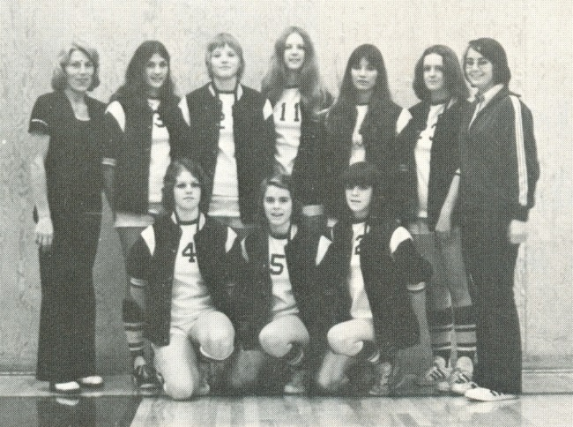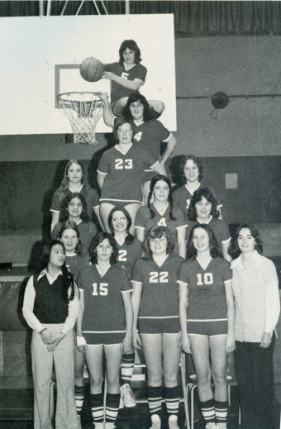
Left: the 1973-74 volleyball team Right: the 1974-75 basketball team
One year later, the Tomahawks senior girls’ basketball team, coached by Pam Henson, made it to the BC Championship for the first time with their fiery sparkplug Sheila Chalmers earning all star honours at both the Island and provincial tournaments. Women’s sporting opportunities increased after American Congress passed Title IX, legislation that stated male and female collegiate athletes should receive equal sporting opportunities. The meant that talented girls could now apply for scholarships south of the border. While few Canadian universities were able to offer “full ride” scholarships, Uvic and other institutions covered tuition and book expenses for their student-athletes, an incentive for strong high school students to continue with their sport at the post-secondary level.
1975-76 was another very successful season in Belmont’s 27 year history, as two teams qualified for provincial tournaments: the swim team, and girls’ cross country. In cross country, Julie Rainey was the top individual performer and helped lead the small group of athletes to a 2nd place finish at the Islands and a 4th place result at provincials. The girls’ team would continue to be an Island powerhouse for the next decade, and in 1979-80, the trio of Karen Rainey, Karen Coutts, and Karen Talmon led the way as Belmont captured both the city and Island titles and finished fourth in BC. At the junior level, Bill Merriman’s school record 37 goals paced the junior boys’ soccer squad to a 2nd place finish at the Islands. This was also the year that girls’ soccer became an official high school sport in Victoria and it wouldn’t take long for Belmont teams to become perennial contenders for city and Island titles.
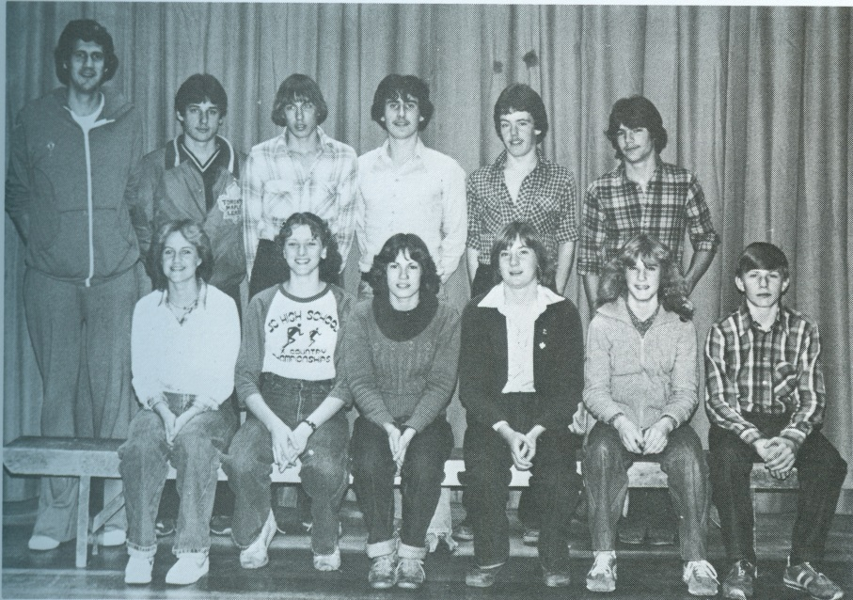
1979-80 Cross country team. The three Karens: Rainey, Talmon and Coutts are sitting in the front row
Coach Randy Smith joined forces with Stan Powell and the duo guided Belmont’s swim team to consistent success for many years. In 1975-76, the swimmers dominated in both the racing and synchronized categories of the competition, capturing bronze and silver medal results in the respective classifications. Doug Portelance, who had won two events at Islands and been a member of the BC championship 400m relay team the year before, once again was the standout performer, taking home an incredible four gold medals at the provincial meet. Other provincial gold medalists from that team were Chris Blaus, Terry Brown, Martin Sabel, Kim Goronuk, Lorraine Morrison, Susan Perry, Julie Rainey, Joan Robertson, Lori Wells, and Chris Wheldon. Some of the swimmers recalled that Coach Powell hosted the year-end team party at his home, which conveniently came equipped with a pool.
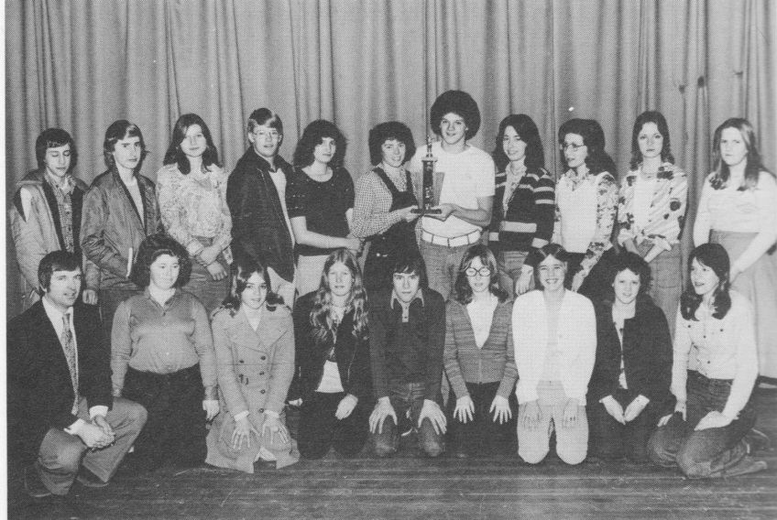
The 1975-76 swim team. Julie Rainey and Doug Portelance are holding the trophy in the back row.
There were a number of other individual female standouts from this decade who pursued their sports after high school. Basketball standout Cathy Auburn became a starter with the Uvic Vikettes and later rowed for Canada’s national team. All- round performer Jan Nowell also played for the Vikettes and was a member of team that went 20-0 in the Canada West Conference in 1975-76. Denise Montgomery Myhre played four seasons of volleyball with Uvic and later excelled in the same sport at the master’s level. Della (Smith) Gwin excelled in both softball and soccer, while sister Kristy (Smith) Evans became Canada’ senior women’s javelin champion and represented her country at the 1986 Commonwealth Games in Edinburgh.
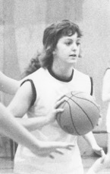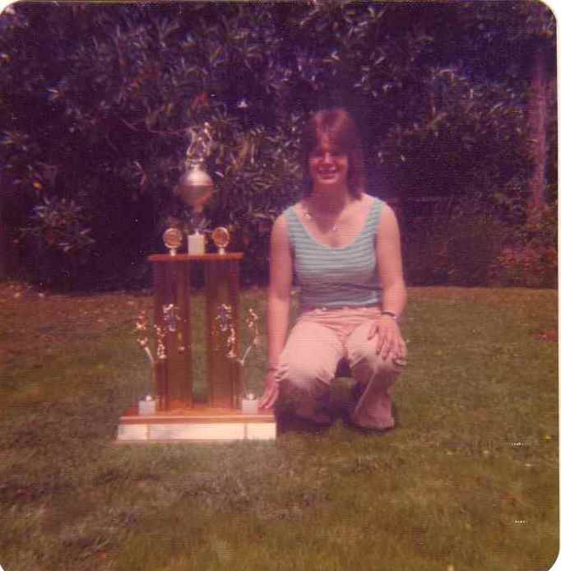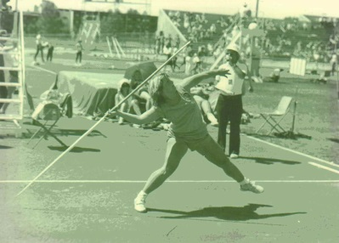
From left to right: Cathy Auburn, Denise Montgomery Myhre, Della Smith Gwin, Kristy Smith Evans

As Belmont teams became more proficient, out-of-town travel expenses became an increasing concern as teams increasingly travelled up Island or to the mainland for tournaments. The basketball teams also often scheduled a major trip during the Christmas break to locations such as Hawaii, Arizona or California. Coaches Muzz Bryant and Bill Spotswood were two of the more active Belmont coaches in regard to fundraising, and their Braves and Tomahawks players chopped wood, organized garage sales, washed cars, helped out at the Colwood Sunday night Bingo events, and sold a variety of goods including chocolates, gift wrap, and poinsettas. Various local businesses generously offered their financial support and agreed to sponsor a Belmont basketball athlete.
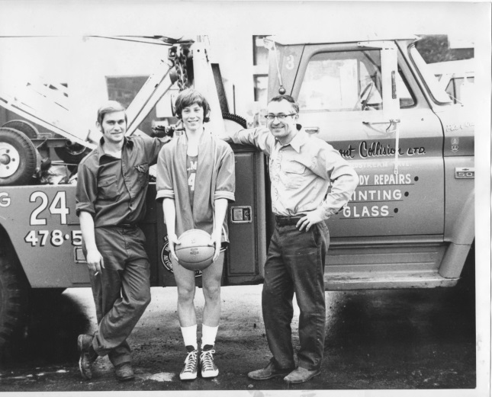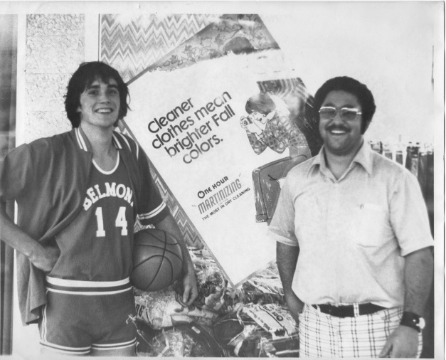
Malcolm Moscrop with his sponsor from One Hour Martinizing
Jim Cochran stands with his sponsors from Belmont Collision
Unlike today, when teams arrange hotel accommodation for out-of-town weekend tournaments, during the 1970’s, visiting teams would sometimes be billeted with players from the hosting school. Besides saving money, this practice allowed the athletes to develop new friendships and fostered a sense of camaraderie. Usually the billeting system worked really well, but there were occasional glitches. In December, 1977, the well-meaning Braves’ basketball players organized a post-game Friday evening social event for their Port Angeles billets, but unfortunately their American guests didn’t enjoy the festivities and asked their coaches to book them into a downtown hotel for the Saturday night. The Port Angeles Daily News reported:
“The 'Rider team and cheerleaders were overnight guests of the Belmont kids Friday night and they got an idea of how their counterparts live, but it wasn't much to their liking. The Port Angeles team didn't like the thought of a lot of "parties" after the games.”
Not only was the Port Angeles contingent reluctant to participate in post-game social events, when the team first entered the Belmont gym “the players and coaches were aghast. The plant was similar to the Stevens Junior High Gym. It wasn't much bigger and the backboards were wooden.”
The Spotswood gym would never be considered one of the premier athletic venues in town, and the lack of spectator seating, along the large pillars that blocked sight lines, meant Belmont volleyball and basketball teams missed out on opportunities to host high-profile events such as provincial championships. However, the gymnasium did receive a significant upgrade when former Braves standouts Lee Edmondson and John Bodman generously donated money to purchase new glass backboards.
The 1970’s marked the end of a long-time Belmont tradition: the house system. Belmont’s first principal Archie Stephenson had originally instigated this comprehensive intramural system in 1948 in an attempt to promote school spirit and physical activity, and generations of students had embraced the camaraderie and friendly competition the program invoked. However, the steady rise of extracurricular athletic and fine arts activities put increased demands on students’ time, and students no longer were able to devote lunch hours and after school to organized intramural competitions.

Bibliography
Bryant, Muzz, interview by Cindy Cullen. Belmont memories (July 2014).
Chapman, Scooter. The Port Angeles Daily News, December 12, 1977: 11.
Edmondson, Lee, interview by Cindy Cullen. Belmont Sporting Memories (February 2015).
Holt, John. "Principal's Message." Legacy, 1976.
Yearbook staff 1970, Sylvia Lang editor. Kee-Yu. Victoria: Belmont, 1970.
Yearbook staff 1971, Jim Kupiak editor. Kee-Yu. Victoria: Belmont, 1971.
Yearbook staff 1972, Philip Mortimer editor. Kee- Yu. Victoria: Belmont, 1972.
Yearbook staff 1973, Liz Hayes editor. Kee-Yu. Victoria: Belmont School, 1973.
Yearbook staff 1974, Cindy Jaggard editor. Kee- Yu. Victoria: Belmont School, 1974.
Yearbook staff. "Dedication." In Legacy. 1974.
Yearbook Staff. Driftwood. Victoria, 1972.
Yearbook staff. Drirftwood. Victoria, 1973.

