Belmont Sports History from the 2000’s
The 2000’s were a highly successful decade for Belmont’s athletic teams, as the school earned two provincial and numerous Island titles. It was also a time of change, with new programs, a new mascot for the school, and the departure of several prominent long-serving coaches.
Mike Toakley's senior girls' volleyball teams continued to excel during this decade and consistently earned recognition in the top ten provincial rankings. Led by first team all-star Nicki Sadowski, the 2000-01 group made it all the way to the provincial final, coming up just a little short in the title match. The 2001-02 team, which included several players from the silver medal squad the year before, achieved their ultimate goal by capturing gold medals at the BC championship, and earning Belmont’s first ever girls’ provincial title. Darla Myhre was selected as the tournament MVP and Andrea Gollmer and Kathy Anderson were first team all stars. Jessica Von Schilling and Danielle Peterson, graduates from Belmont teams in the later 2000’s, both had outstanding careers with the UBC Thunderbirds, winning many national titles between them.
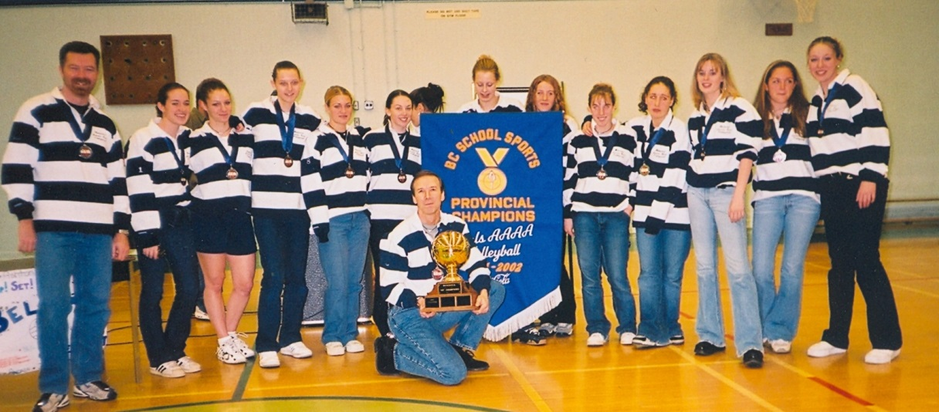
Belmont’s 2001-02 girls’ volleyball team with their provincial championship banner

On the boys’ side, Matt Balchin starred at the University of Manitoba and was selected as an all star at the CIS national tournament. The Belmont volleyball program established a strong connection with Camosun College and a number of former Bulldogs helped the Chargers attain outstanding results in the 2014-2015 season. Libero Jamie Rodstrom was a member of the women’s squad that won the bronze medals at the Canadian championship tournament, while four Belmont grads: Alex Sadowski, Doug Waterman, Taran Silas and Mark Severinson helped the men’s team capture the school’s first ever national championship title. Alex was named a first team All Star in conference play and earned the same honour at the Canadian tournament, while Doug was named to the conference All Rookie team.
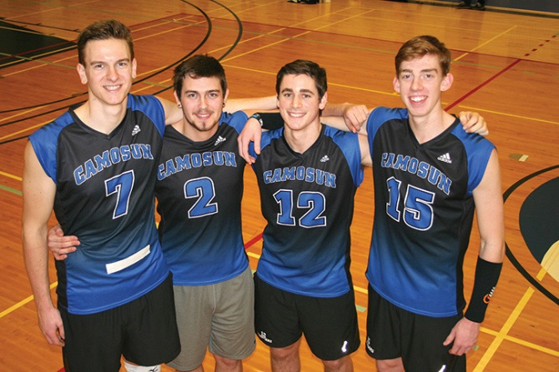
Belmont grads Alex Sadowski, Taran Silas, Mark Severinson, and Doug Waterman in their Camosun Chargers jerseys (Goldstream Gazette Don Descoteau photo)
In May 2002, Ken Lowe’s golf team of Dustin Pewarchuk, Cody Pewarchuk, Dan Roberts, Adam Cracknell, and Julianne Kim placed first at the provincial tournament and brought home Belmont's second championship banner of the decade. Nine years later, in 2010-11, the golf team of Dylan Bell, Brock Holland, Darren Day, Vince Michaud and Sean Orr won silver medals at the BC high school championships.
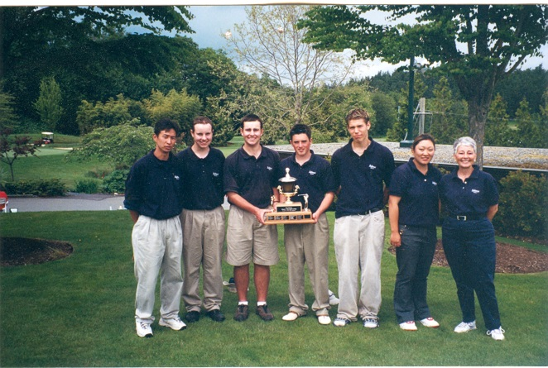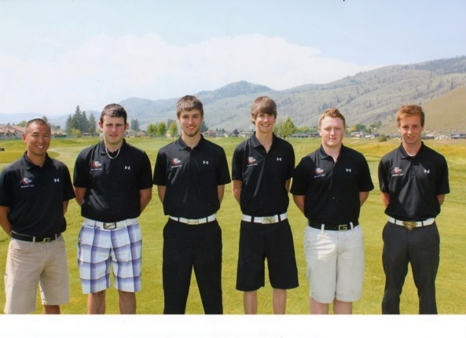
2010-11 Golf Team: 2nd in B.C.
2001-02 Golf Team: Provincial champions

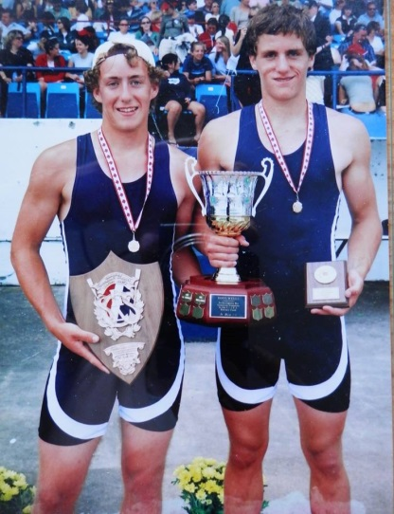
In 2004, Danny Buchanan and Keith Siklenka won the pairs event in the BC championship rowing regatta and became Canadian junior men's champions a few months later, a truly amazing accomplishment!
The 2005-06 tennis squad, that contained a mixture of Victoria athletes and international exchange students from a variety of countries, upset perennial champions Oak Bay to win the Vancouver Island championship and became the only Belmont tennis team ever to advance to the provincial tournament. An upset victory against Oak Bay in the Island tournament also played a prominent role for the 2007-08 senior boys' basketball team, as they rewarded retiring coach Muzz Bryant with his first Vancouver Island title after over three decades of coaching the senior boys.
Coaches Muzz Bryant (kneeling) and Tom Holmes (standing behind Muzz) and the 2007-08 Island Championship BBall Team
Keith Siklenka and Danny Buchanan

Individual athletes also created impressive legacies. The Huzzey sisters, Megan and Kaitlin both became provincial high school champions in the race walk event. Megan captured three consecutive Canadian junior titles for the 10 kilometer race walk and would later compete internationally for Canada. Manvir Sahota, a two time provincial wrestling champion, won the silver medal at Nationals while a grade 12 student at Belmont.
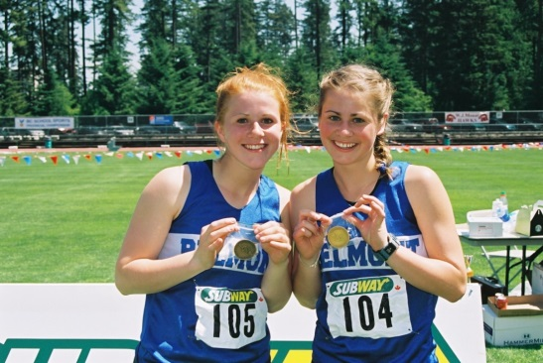
Kaitlin and Megan Huzzey (left) and Manvir Sahota (right)
Danielle Bell was a talented swimmer who won the 1500 meter freestyle at the national championship meet and competed in the 2002 Commonwealth Games. Speedster Katie Nelson won two consecutive national titles in the 400 meters in her age group at the Canadian Track and Field Championship and also was a gold medalist at the BC Summer Games. Katie’s older brother Mark was one of the top cross country and middle distance runners in the province and went on to compete collegiately. Julia Tschanz was another Belmont athlete who shone in track and field. She became one of Uvic’s top cross country and middle distance runners and medalled in a number of CIS competitions.
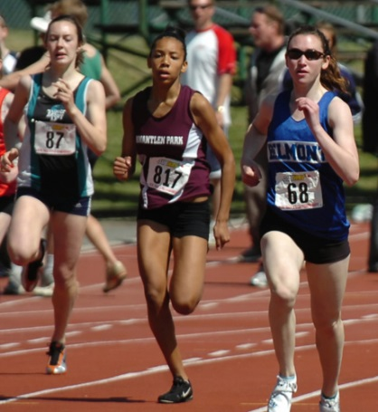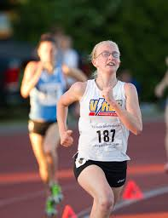
Julia Tschanz racing for UVic (Vikes photo)

Katie Nelson (#68) at the BC Track and Field Championship
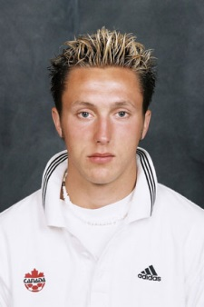
Although Belmont soccer teams may not have medalled at the provincials between 2000 and 2015, there were many strong teams and some outstanding individual performers. Josh Simpson and Liam Girard were perhaps the two most accomplished Belmont players ever. Josh, who is a professional player in Europe, became involved with the national program as a teenager and has been a stalwart member of Canada’s team for the past ten years. Liam was a member of Canada’s U-17 team and earned a full scholarship to the University of Denver. He also played professionally in the MLS. Other strong players included Mike Seager, Dave Seager, Paul Vandenboomen, and the Salvati brothers Chris and Nico.
Liam Girard
Josh Simpson with Team Canada
On the female side, Rachelle Armstrong and Moira Hood were mainstays of the 2003-04 girls’ team and both players went on to excel at the post-secondary program. Rachelle was the leading score on the Trinity Western team that won the CIS national title in 2004, and Moira was a Uvic standout for five years. Kristen Livingstone captained the powerful 2012-13 Belmont squad and now plays at the University of Alberta.
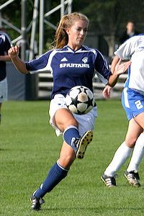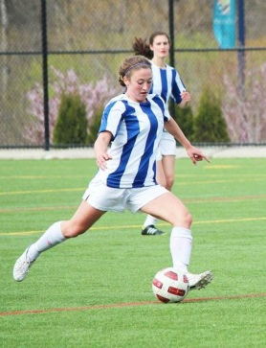
Kristen Livingstone
Rachelle Armstrong
Other Belmont grads made their mark in a variety of sports. Tyler Hass, a very talented multi-sport athlete, starred as a Uvic Vikes basketball player for 5 seasons and also suited up for the Victoria Shamrocks lacrosse team, joining fellow Belmont grads Chris Wardle and Cody Hagedorn. Brody Eastwood, who played for the Junior Shamrocks with Chris and Cody, and earned an NCAA scholarship, was selected in the first round of the WLA draft by the Nanaimo Timbermen . Several of these players also played at the professional level in the MLA.
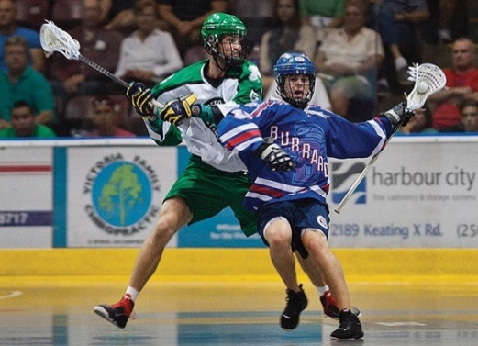
Tyler Hass with the Victoria Shamrocks
In football, offensive lineman Tim O’Neill was recruited by the University of Calgary Dinos after starring with the Westshore Rebels. He then moved onto the CFL and enjoyed a successful career with the Calgary Stampeders and Hamilton Tiger Cats that included a Grey Cup victory in 2008. The Walushka boys, Kris and Darcy were softball standouts who both played for Team Canada, Darcy for the junior national squad while still in high school, and Kris for the senior national team. Tyson Barrie was a junior hockey star defenceman for the Kelowna Rockets and a member of Canada’s silver medal team in 2011 and now plays in the NHL for the Colorado Avalanche. Adam Cracknell, a member of Belmont’s BC Championship golf team in 2002, is also in the NHL today, playing for the Columbus Blue Jackets.
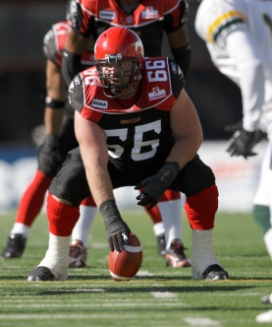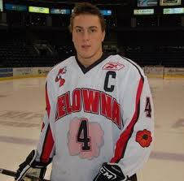
From Left to Right: Tim O’Neill, Darcy and Kris Walushka, Tyson Barrie, Adam Cracknell
Belmont athletics underwent a significant change in 2001-02, with the school adopting a new nickname for the school’s sports teams. This was a lengthy process initiated by students in Paul Waterlander’s First Nations Studies 12 class who felt the names Braves and Tomahawks (which were still primarily associated with the boys’ and girls’ basketball teams) portrayed negative stereotypes about aboriginal culture and were no longer appropriate as 21st century mascots. After extensive debate and a school-wide contest, the Bulldogs were selected as the new mascot and all the teams adopted the new name and logo.
In 2014-15, as school staff and students prepared for the transition to the new building on the former Glen Lake site, the issue of the Belmont mascot came up again and stakeholders debated whether to keep the Bulldog moniker or examine new possibilities.
The 2000’s saw other significant changes. New athletic opportunities were created by the Sooke School District, and Belmont established hockey and soccer academies to allow highly motivated students high performance instruction. Langford council, under the leadership of Mayor Stewart Young, were extremely supportive of Belmont athletics and allowed the school access to some of the city’s facilities, including the turf fields at Langford City Park and the Eagle Ridge Arena. The academies would not have been feasible without this generous assistance.
In 2009, Kevin Harrington, with the assistance of Dave Bennett and other community coaches instigated a new football program, which developed from the Tier 2 level into a strong AAA program that could compete with the best teams in the province. Several alumni were members of Team BC and also played either for CIS university teams or the Westshore Rebels after graduating from Belmont.
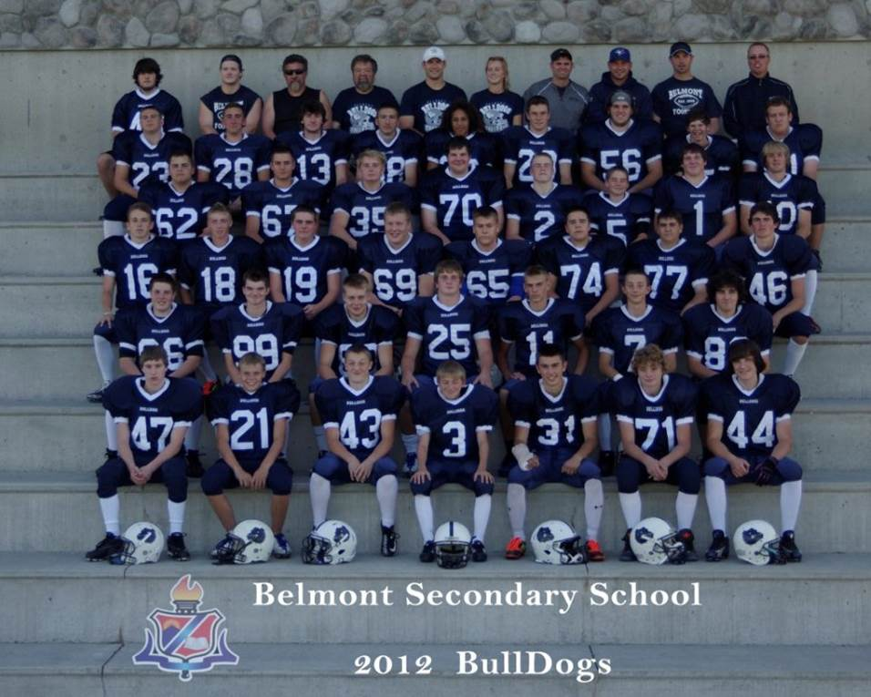
Along with the many positive accomplishments, the 2000’s also saw the loss of several long-time Belmont coaches who had been instrumental in helping the school reach athletic excellence. Bill Spotswood passed away in 2002 after a lengthy battle with cancer, through which he continued to coach girls’ basketball right up until a few months before his death. His memorial service was held in the original 1956 gymnasium which was renamed in his honour.
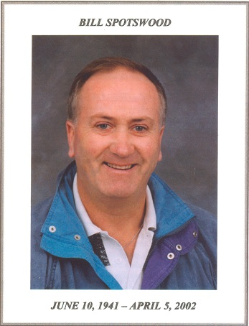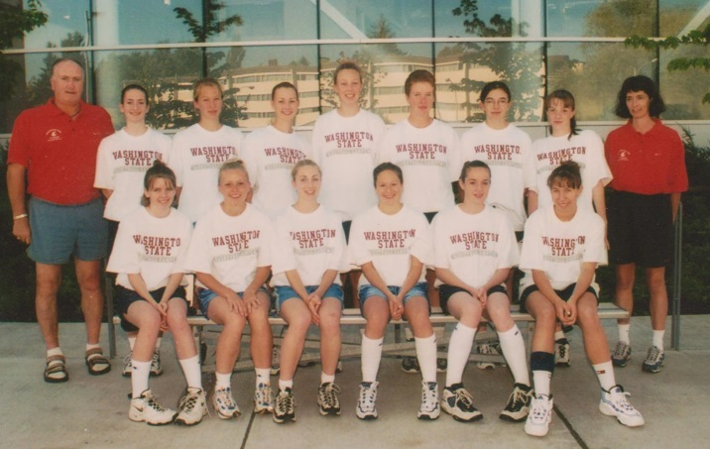
Bill at the summer Washington State University basketball camp with members of Belmont senior girls’ basketball team

Some other prominent Belmont coaches who retired during this time period were Muzz Bryant, Patti O’Neill, Tom Holmes, Valerie Baker, Rex Johnson and Lloyd Powell.
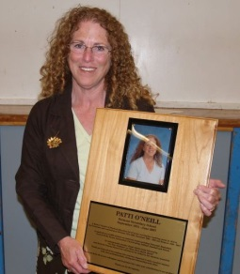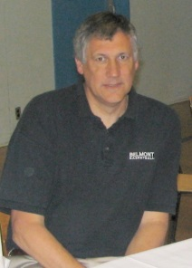
Belmont retiring coaches Muzz Bryant, Patti O’Neill, Tom Holmes, Valerie Baker, Rex Johnson, and Lloyd Powell

In September of 2015, Belmont School is scheduled to re-open in its new location. The new facility features impressive athletic facilities, including one of the largest high school gymnasiums in the province, as well as new playing fields. Once again, Langford council has expressed their desire to develop a partnership with the high school and to support its athletic programs with the use of the playing fields and arena. With the pending construction of a YMCA building and pool close by, as well as the expansion of Rugby Canada on the adjoining property, it seems likely that Belmont’s athletics will continue to prosper and that new generations of young athletes will add to school’s rich sporting legacy.

