Tim O’Neill
Tim, perhaps the most accomplished football player ever to attend Belmont, was a strong athlete who participated in baseball, soccer, and basketball before deciding to focus on football as his primary sport. He came up through the community ranks, playing with the Spartans before moving up to the Victoria Rebels. Tim says that Rebel coach John Cardilicchia was a huge positive influence on him and was instrumental in his development into an elite athlete.
After playing several seasons of junior ball with the Rebels and starring as one of the top linemen in the league, Tim was recruited by the University of Calgary Dinos. In 2002, he joined the Dinos as a 22 year old rookie. His first few seasons, he played guard on offense and sometimes was also pressed into service on the defensive line. In 2005, he was named to the conference All Star team and was drafted by the Edmonton Eskimos of the CFL. After taking a year off school to explore professional opportunities, Tim returned to the Dinos for his final season of eligibility and earned CIS first team All Canadian honours as a centre. He also graduated with his Fine Arts degree.
Tim signed with the CFL Calgary Stampeders in 2008 and the team won the Grey Cup that year. At 6’3” and 300 pounds, he was a commanding physical presence, and was a key member of the Stampeders’ offensive line for another four seasons before moving to the Hamilton Tiger-Cats in 2012. He made an immediate impact with his new team, and the Tiger-Cats nominated him for the CFL’s most outstanding lineman award in 2012. Tim experienced two more Grey Cup games with the Ticats, in 2013 and 2014, but unfortunately the team came up a little bit short each time.
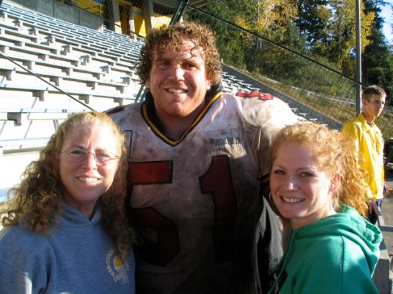
Tim owns a home in Metchosin and returns home to train in the off- season. He gives back to the community by helping out with Rebels camps and mentoring younger players. When asked if he had any advice for aspiring Belmont athletes today, Tim replied that it is important to set goals, but to make sure that they are measurable.
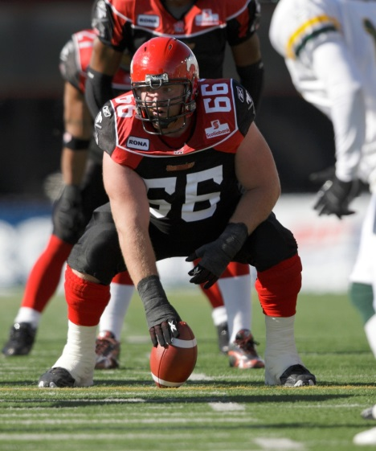
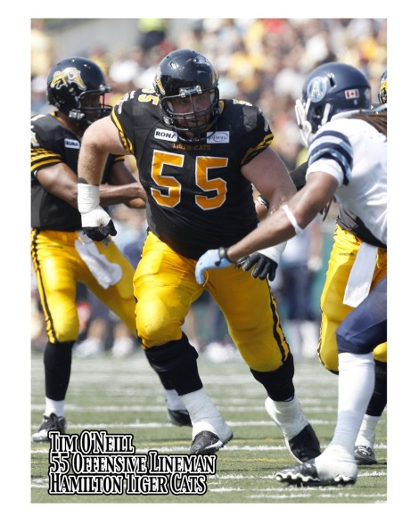
Tim as a Hamilton Tiger-Cat
Tim as a Calgary Stampeder
Tim with his mom Patti and sister Erin, both of whom are Belmont alumni
Tim as a Hamilton Tiger Cat
Tim as a Calgary Stampeder
Tim with his mom Patti and his sister Erin

