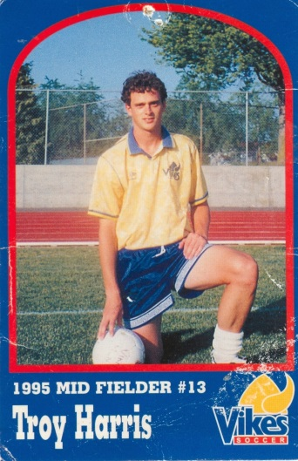
Troy Harris: 1984-1989
Troy attended Belmont in 1984-85 as a grade 8 student coming from Glen Lake Elementary School. He was part of the last group of grade 8's to ever go to Belmont. After that year, the grade 9’s and 10’s had to go to either Spencer or Dunsmuir (depending on catchment area - where you lived) for 2 years before returning to Belmont for grades 11 and 12. After two years at Spencer, Troy returned in 1987-88 (his grade 11 year) and graduated from Belmont in June, 1989.
At Belmont, Troy played soccer and basketball. He first became active in competitive sports when he was four or five years old - playing softball in the community. Eventually Troy moved to baseball (hardball) at age 8 or 9 and played that sport until he was 16. At 8 years old he first began playing soccer for JDF. He always played sports at school as well as in the community because he felt it was an honor to play for his school team. Troy’s top sporting accomplishment at Belmont was playing on the Belmont Braves basketball team in his grade 12 year. The Braves had a very strong team that finished third in Islands and played in a challenge game to get to BC's (unfortunately they lost that game). As well, he was captain of the Sr. boys’ soccer team. Troy’s best Belmont sports-related memory was probably all the trips we went on with basketball. “It was such a great way to connect with your teammates.”
Troy notes that “Sport has always been and will always be a very important part of my life”. He became a PE Teacher to allow athletics to continue to be a focus in his life. Troy would say that winning numerous championships with Gorge FC (5 league and playoff championships, 2 provincial championships, and 2 National Championship appearances winning a Silver Medal) were highlights of his soccer career. But perhaps the most significant accomplishment of all was his four years’ experience playing soccer for the University of Victoria Vikes men's team. He had the chance to travel all over North America playing soccer with and against some of the best players and teams on the continent. On his Florida tour in 1993, the Vikes played against the under 21 men's national team from Argentina and won 2-0. Troy’s Uvic experience culminated in 1996 when he won a National Championship as a member of the Vikes.
Peter Songhurst (Spencer and Belmont teacher and coach) had a significant impact on Troy as an athlete. He was the type of person, coach, and teacher that Troy wanted to emulate. As well, Bruce Wilson, his UVic coach, also impacted his athletic career in terms of always wanting him to compete on a daily basis. He made Troy a better and harder working player. Finally, Troy would say that his mom was a huge influence and that she supported him in all his athletic endeavors.
Troy believes that“the key to being a successful athlete is hard work and having a great attitude. Every coach wants to work with that type of player. Hard work makes dreams reality.”
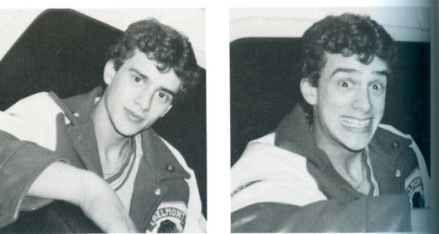
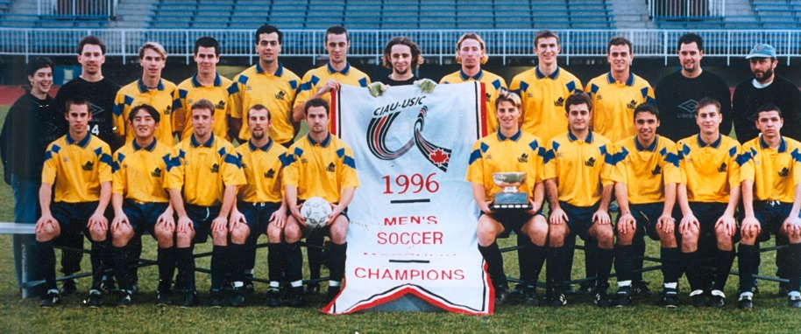
Troy is standing third from the right with his Uvic team-mates after winning the national championship.

