Tyson Barrie: 2006-2009
Colorado Avalanche defenceman is the top hockey player to ever graduate from Belmont. A talented natural athlete, Tyson participated in a number of sports as a youngster, including hockey, lacrosse, soccer and basketball, but by his early teens, hockey became his primary athletic focus. His father Len, a former NHL player himself, provided encouragement and guidance as he coached Tyson throughout his Juan de Fuca minor hockey career. Tyson was one of the leaders on the powerful Juan de Fuca Grizzlies squad that captured the provincial major midget title in 2006-07. Tyson considers this to be his best sporting accomplishment before moving onto the WHL. The Grizzlies were one of the strongest midget teams ever assembled in Victoria and Tyson recorded 130 points in 72 games. These impressive numbers obviously caught the attention of the WHL Kelowna Rockets, which selected him in the 2007 bantam draft.
Tyson relocated to Kelowna the following year as a 16 year old grade 11 student. He would remain with the Rockets for the next four seasons and develop into one of the top defenceman in the country. Some of the highlights of his junior career included winning the WHL title in 2009 and playing for Canada’s silver medal team at the World Junior Championships in 2011.
Despite spending the majority of each school year in Kelowna, Tyson returned to Belmont in the spring for both his grade 11 and 12 years in order to finish up his classes at the Langford School. He explained that he came back to Victoria because that’s where his family lived and to Belmont because that’s where all his best friends were. He added that he has a lot of good memories from Belmont and that he “was always back for the end of the school year so the weather was always getting nice so we would spend a lot of time outside!”
Tyson’s rise up the hockey ranks continued after he was drafted by the Avalanche in 2009. He started his professional career playing for Colorado’s AHL affiliate, the Lake Erie Monsters, where he put up impressive offensive numbers and earned All Star honours. In 2011-2012, he was called up to the Avalanche.
Tyson credits a lot of people for helping to influence his hockey career, but says his dad would have to be at the top of the list. In fact, he still talks to Len after every game. And although he is already an accomplished NHL regular, Tyson still has some major goals he hopes to achieve. Obviously winning a Stanley Cup is a future objective, and he would also love to compete at the Olympics and have the honour of representing Canada once again.
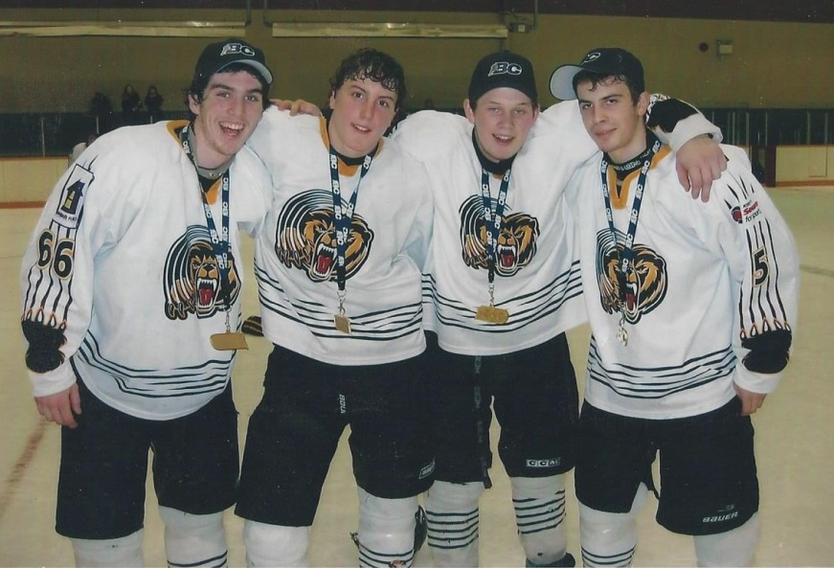
His advice for aspiring Belmont athletes today is to work hard and to follow your dreams for as long as you can.
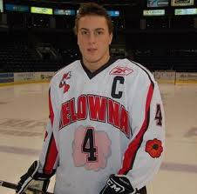
Tyson as a member of the WHL Kelowna Rockets
Tyson (2nd from left) with Juan de Fuca Grizzlies team-mates Sean Robertson, Cody Carlson, and Aaron Gunn

