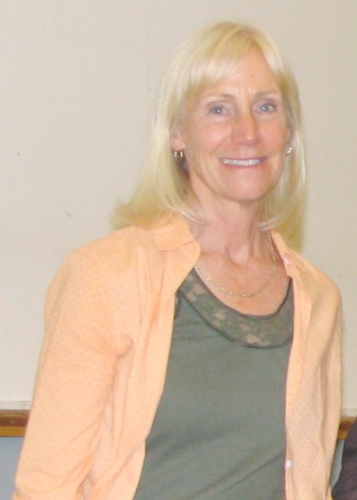
Valerie (Dalgleish) Baker: 1976- 1984 and 1993-2010
“I love the way Ms. Baker takes care of us on road trip! She’s like a second mom to all of us.”
One of the Belmont junior girls’ basketball player uttered words to this effect at a Courtenay hotel in December, 2007 and her team-mates wholeheartedly agreed. Val’s co-coach, Cindy Cullen, was standing nearby and overheard the conversation. She knew exactly how the girls felt. Coaching with Val meant the paperwork would be completed, permission forms collected, and the hotel booked well in advance for any out-of town trips. The first aid kit would be restocked, not just with ice-packs, bandages, and other basic medical supplies, but also with articles such as hair elastics, extra shoelaces, gum, deodorant, Kleenex tissues, personal hygiene products, and any other item a teenage girl might possibly forget to pack in her gym bag. There would be individual water bottles laid out on the bench for each player during warmup, sometimes even with their initials labelled in black sharpie to avoid confusion. And there was always a little snack, sometimes healthy store-bought granola bars, but more often home-baked treats of some kind. No wonder the girls felt so well cared for!
Val had the ability to make people feel special. She had a kind, warm personality and genuinely cared about each athlete as an individual. She feels that she was not as competitive as many coaches of that era as her primary goal was to ensure that everyone had a positive experience and felt good about themselves and their team-mates. The win-loss record was secondary, although she does admit, “Ok, about the competitive part.....it was sweet to beat Oak Bay! Val’s coaching style was very much one of inclusion, and her athletes were consulted regularly and had input into most decisions. She stressed sportsmanship and teamwork and discouraged individualism or overly competitive play. The trust she showed towards the players often resulted in them steadily improving as the season progressed, and many times, shy or anxious youngsters blossomed into confident self-assured performers under her encouraging tutelage.
Val attended in a small, rural high school where there weren’t enough students to have to have tryouts and make cuts. She was a multi-sport athlete who particularly enjoyed field hockey, swimming and basketball, all sports that she later coached at Belmont. Val attributes her success in sports more to hard work and a desire to improve rather than on outstanding natural ability. She always admired those same affective qualities in the players she coached, and made sure that the less skilled athletes with great attitudes and work ethic were rewarded with at least some playing time. She also had no hesitation benching a player who was disrespectful towards officials, overly aggressive towards an opponent, or demeaning to a team-mate.
During her first stint at Belmont, Val coached the girls’ field hockey team. She loved the constant movement and the intensity of the girls who chose to play this sport. They just wouldn’t give up and were physical on the field, but ladies off the field! The 1976 field hockey team stands out as one of her most memorable teams because they had so much spirit and played with a lot of class. They didn’t win a lot of games that season but the girls were such good sports.
Tennis was another one of Val’s favorite activities to coach, and she took over the Belmont program after she returned from a ten year interlude at Dunsmuir. She says that she enjoyed the fact it was a combination of individual, dual and team sport. Belmont tennis teams often consisted of an eclectic group of athletes, and often included several local Victoria students mixed with an assortment of international students from a variety of countries. Most years, they didn’t win many matches, but they did have lots of fun. In 2005-2006, however, a group of mostly German exchange students who were very accomplished players joined up with a smaller number of Belmont students who had honed their tennis skills outside our school program and formed a powerhouse squad. The team had tremendous success and ended up winning the Island Championship in a major upset, dethroning a heavily-favoured Oak Bay group that had won the tournament for many years in a row. Belmont advanced to the provincial tournament in Vancouver and placed 6th, a memory Val relishes because it was such a great experience for all the players.
Val’s favorite part about coaching was getting to know the players on a different level than teaching them. They all wanted to be there, and there was also the added bonus of getting to know some of the parents. The only negative aspect was the time it took her away from her own family.
Val Baker will be remembered by her players and colleagues as a kind-hearted, high organized, principled and fun-loving individual who coached for the all the right reasons and was a positive role model for others.

